American Journal of Political Science (Forthcoming)

The Political Consequences of Depression: How Conspiracy Beliefs, Participatory Inclinations, and Depression Affect Support for Political Violence

Short title: The Political Consequences of Depression

Keywords: Political violence, depression, conspiracy beliefs, participation, January 6th, COVID-19, Public Opinion

Matthew A. Baum
matthew_baum@hks.harvard.edu
Harvard University
Harvard Kennedy School
79 JFK St., Cambridge, MA 02138.

James N. Druckman
druckman@northwestern.edu
Northwestern University
Department of Political Science
Scott Hall
601 University Place
Evanston, IL 60208

Matthew Simonson
msimonso@sas.upenn.edu
University of Pennsylvania
133 S. 36th Street
Philadelphia, PA 19104-6215

Jennifer Lin
JenniferLin2025@u.northwestern.edu
Northwestern University
Department of Political Science
Scott Hall
601 University Place
Evanston, IL 60208

Roy H. Perlis
rperlis@mgh.harvard.edu
Harvard Medical School
Massachusetts General Hospital
185 Cambridge St, 6th Floor
Boston, MA 02114

*We thank Jon Green, David Lazer, Jennifer Lerner, Julia Minson, Phil Potter, Alauna Safarpour, and Lauren Young for thoughtful comments. We acknowledge financial support from the National Science Foundation under grants SES-2029292, SES-2029297, and SES-2116645, and the Peter G. Peterson Foundation.

The Political Consequences of Depression: How Conspiracy Beliefs, Participatory Inclinations, and Depression Affect Support for Political Violence

ABSTRACT
Depression can affect individuals’ attitudes by enhancing cognitive biases and altering perceptions of control. We investigate the relationship between depressive symptoms and Americans’ attitudes regarding domestic extremist violence. We develop a theory that suggests the association between depression and support for political violence depends on conspiracy beliefs, participatory inclinations, and their combination. We test our theory using a two-wave national survey panel from November 2020 and January 2021. We find that among those who hold conspiracy beliefs and/or have participatory inclinations, depression is positively associated with support for election violence and the January 6th Capitol riots. The participatory inclination dynamic is particularly strong for men. Our findings reveal how the intersection of two concerning features of American society – poor mental health and conspiratorial beliefs – strongly relate to another – support for political violence. The results also make clear that interventions aimed at addressing depression can potentially have substantial political consequences.
Replication Materials: The data, code, and any additional materials required to replicate all analyses in this article are available on the American Journal of Political Science Dataverse within the Harvard Dataverse Network, at: https://doi.org/10.7910/DVN/XMHS0J

Word Count: 9,999

Depression can affect individuals’ attitudes by amplifying cognitive biases and altering perceptions of control (Park et al. 2016). This can have important political implications. Researchers have found links between depression and reduced political participation (Landwehr and Ojeda 2021), increased gun ownership (Simonson et al. 2021), and reduced support for right-wing parties (Bernardi 2021). Others look at how politics affect mental health, showing, for example, that the current highly polarized state of American politics may lead to sleep loss and emotional distress (Smith et al. 2019). Nonetheless, despite media attention to the possible role of severe mental illness in a small minority of mass shootings, academic research suggests only a weak, and not necessarily causal, association between depression and committing acts of violence (Skeem and Mulvey 2020). Even less certain is whether depression correlates with support for political violence, and if so, under what circumstances. Notwithstanding these examples, political science research mostly ignores mental health. The present study seeks to fill this gap by investigating whether and how mental health during the COVID-19 pandemic related to Americans’ attitudes regarding domestic extremist political violence in the context of the 2020 election and the January 6th storming of the U.S. Capitol. Ultimately, this provides insight into the relationship between individuals’ mental health and the nation’s political health.
We specifically assess the association between depressive symptoms (henceforth referred to as “depression”) and support for political violence in the United States, which is of increasing concern to political scientists (Kalmoe and Mason 2022), the government (Doxsee and Harrington 2021), and the public (Frankovic 2021). Amid concerns of democratic backsliding (Graham and Svolik 2020), understanding the correlates of support for political violence is of crucial importance. We do this by identifying the conditions under which depression is associated with attitudes towards violence. We then test our hypotheses with a large panel survey that included three operationalizations of support for violence (both actual and hypothetical), before and after the January 6th Capitol insurrection.
Our findings support our expectations: we find that among those who hold conspiracy beliefs and/or have participatory inclinations, depression is positively associated with support for election violence and the Capitol riot. These findings, regarding a participatory inclination, are particularly robust for men. They also show that the intersection of two widely discussed and concerning features of American society – depression and conspiratorial beliefs – associate with another alarming outcome: support for political violence. It is thus plausible, if the relationship is causal, that interventions to reduce depression could substantially reduce support for violence (as we show below, potentially by 15 percentage points or more).
To be clear, individuals suffer from depression for reasons over which they have little or no control; our findings suggest that taking steps to vitiate the illness (rather than criticize those experiencing it) could be vital not only for personal and public health but also for democracy. We also emphasize the ethical and logistical difficulty of experimentally manipulating depression; thus, many findings in this area cannot be causally definitive. We use panel data to somewhat address this concern, while also acknowledging inferential limitations. This also means, from a policy perspective, one cannot assume a reduction in depression (in the presence of conspiracy beliefs and/or participatory inclinations) will invariably lead to reduced support for violence. Still, our findings make clear that mental health, conspiracy beliefs, participatory inclinations, and support for political violence are strongly interrelated.
The Psychology of Support for Political Violence
Democratic backsliding can occur via violent overthrows (e.g., coups) or the gradual erosion of democratic norms (Levitsky and Ziblatt 2018). Scholars of American politics have recently focused on people privileging their partisan goals over democratic processes either by justifying partisan violence (Kalmoe and Mason 2022) or endorsing the violation of norms (Graham and Svolik 2020). We explore support for and acceptance of actors who engage in violence against the government (as opposed to personally engaging in violence). This need not involve partisan motivations among competing sides with distinct ideologies. Rather, it can entail the acceptance of violence as a way of managing conflict (Peirce 1877). It normalizes violence for those who engage in it and thus may embolden them; it involves the devolution of a norm against violence. Specifically, we study the factors connected with support for violence in a particular context (presidential elections) and in response to a specific event (the January 6th insurrection). These types of supportive attitudes can signify democratic backsliding (Bermeo 2016).
When Does Depression Exacerbate Support for Violence?
Depression is a common mood disorder where an individual experiences a persistent feeling of sadness and hopelessness and/or loses interest in most activities. The Diagnostic and Statistical Manual of Mental Disorders, Fifth Edition (DSM-5), states that a diagnosis of a major depressive episode is appropriate when an individual experiences five or more of nine identified symptoms for at least two weeks. These include a depressed mood, diminished interest in daily activities, significant weight loss or gain, sleep difficulties, slowing of thought and reduction of physical movement, fatigue, feelings of worthlessness or excessive guilt, diminished ability to concentrate or make decisions, and recurrent suicidal ideation. In 2019, roughly 7% of U.S. adults experienced moderate or severe depression (Villarroel and Terlizzi 2020). This jumped with the COVID-19 pandemic to roughly 33% in 2021 (Ettman et al. 2022). Even during less traumatic times, depression constitutes a leading cause of disability (Mathers 2008) and is the most prevalent mental health disorder in advanced societies (Lépine and Briley 2011). Further, as Ojeda (2015: 1226) aptly states, “depression is a political phenomenon… it has political consequences” (italics in original). While Ojeda and a few others explore depression’s relation to various aspects of politics (e.g., Bernardi 2021; Smith et al. 2019), support for political violence has largely evaded attention.
This is a difficult topic due to common media portrayals of violence (e.g., mass shootings) as stemming from mental health problems (Dewan 2022). This simplistic and inaccurate depiction risks stigmatizing those suffering from mental illness. At the same time, it is important to understand the conditions under which mental health may contribute to support for political violence, considering concerns about the rise of both phenomena. It is a question that thus far has no clear answer (Misiak et al. 2019). There clearly does not exist a one-to-one relationship between mental illness generally, or depressive symptoms specifically, and support for violence (or violent acts) (Skeem and Mulvey 2020). The question becomes whether facilitating factors increase the likelihood of such a relationship.
To address this question, we first note that depression is often accompanied by a sense of a loss of control, particularly an external locus of control. This brings with it a feeling that outcomes depend on powerful others, chance, fate, or luck (e.g., Cheng et al. 2013; Wiersma et al. 2011). Depression also operates as a heterogeneous concept, reflecting a range of disorders with highly variable features and pathophysiology (Buch and Liston 2021). In some instances, perhaps the modal instance, depression generates fear, passivity, and a loss of interest due to feelings of low control (O’Connor et al. 2002) – a situation that often quells efforts to regain control and lowers self-efficacy. Such scenarios dampen political activities; indeed, Landwehr and Ojeda (2021) show that, across four countries, depressive symptoms substantially reduce the probability of voting by diminishing political motivation and physical energy (also see Ojeda 2015; Ojeda and Pacheco 2019; Ojeda and Slaughter 2019). While not explored, it follows that depression would, if anything, decrease support for political violence, given reduced expectations of the possibility of regaining control or inducing change.
In other instances, those suffering from depression experience aggressiveness or anger (Fava 1998; Judd et al. 2013) that prompts them to seek to regain their lost sense of control (Crona et al. 2017). They can do this by taking or supporting actions, including those that are violent. One such lever is conspiracy beliefs – that is, efforts to explain an event by invoking the machinations of powerful people who attempt to conceal their role while pursuing malevolent goals (Sunstein and Vermeule 2009). Conspiracy ideation comes in many guises, including allegations that governmental entities act for nefarious purposes (van Prooijen and Douglas 2017). When someone with depression adopts governmental conspiracy theories, they: 1) gain a sense of control by providing explanations for what is wrong (Moulding et al. 2016; van Prooijen and Douglas 2017), 2) gain a target of attribution for feeling poorly (Levinsson et al. 2021), and 3) lose trust in the system, leading to a belief that change (and, consequently, regaining control and feeling better) needs to occur through extra-systemic processes that include supporting violence (Webber et al. 2020). Conspiracy theories thus produce narratives that can lead someone suffering from depression to support violence, thinking it can increase control and decrease depressive symptoms.
H1: All else equal, depression will be positively associated with support for political violence when accompanied by high levels of conspiratorial beliefs (relative to when it is not accompanied by such beliefs).
Another factor that could prompt a control response is activity level. For example, Toker and Biron (2012) show that, generally, engaging in activity tempers depression by providing a sense of control. Of course, as mentioned, those with depression are relatively less likely to participate politically; however, participation has a habitual component (e.g., Aldrich, Montgomery, and Wood 2011). Thus, in politics, those with such a participatory inclination (i.e., regularly, or recently participated in politics) may view political action as a means of regaining control. Along these lines, Montgomery Dumas, and Torres (2015) show that political participation fosters perceptions of control such that individuals feel capable of altering political outcomes: “engagement itself can affect subsequent control beliefs” (8; also see Skinner 1996). Thus, an individual with a high participatory inclination who experiences depression will likely view taking or supporting political actions as a means of regaining control. Such participation can include supporting political violence, for two reasons. First, from the perspective of those with otherwise high participatory inclinations, depression will relatively reduce feelings of self-control (as explained) and lower self-control correlates with supporting violence (Perry et al. 2018; Rottweiler and Gill 2022). Second, from the perspective of those otherwise experiencing depression, participatory inclinations will counter the feelings of insignificance that depression engenders and embolden taking actions, including supporting violence (Bartusevičius et al. 2021). Notably, supporting violence can increase feelings of significance (Kruglanski et al. 2014: 59; Molinario et al. 2022). Thus, the intersection of depression and a high participatory inclination increases the likelihood of supporting violence.
H2: All else equal, depression will be positively associated with support for political violence when accompanied by a high participatory inclination (relative to when it is not accompanied by such an inclination).
Finally, in combination, conspiratorial beliefs and a high participatory inclination will reinforce one another and lead to even greater support for violence among depressed individuals. Conspiracy beliefs provide a target, and a high participatory inclination offers a vehicle for control. This mix, given that it envelops an attribution and a mechanism, should generate even more support for violence than the presence of either moderating factor on its own.
H3: All else equal, depression will be most strongly positively associated with support for political violence when accompanied by both high levels of conspiratorial beliefs and a high participatory inclination (relative to when only conspiratorial beliefs or a high participatory inclination are present).
In sum, we predict that, given conspiracy beliefs and/or a high participatory inclination, the passivity underlying depression is transformed into action, leading to a relationship with support for violence. These variables mean those suffering from depression become more likely to view violence as a pathway for regaining control and significance, and hence support it.
In addition to our three hypotheses, we offer a corollary based on research suggesting that, relative to men, women tend to exhibit a greater prevalence of depression, starting in late adolescence (Piccinelli and Wilkinson 2000), and employ distinct coping strategies (Nolen-Hoeksema 1995). Butler and Nolen-Hoeksema (1994) summarize that “[M]ales are more likely to engage in active, distracting, or mastery-oriented responses to their depressed moods” (333). This contrasts with women, who tend to be less active and instead ruminate over the causes and implications of their depression (Piccinelli and Wilkinson 2000: 489). Men will be more apt to react to depression by seeking out active control. This implies we may see stronger effects of depression in interaction with conspiratorial beliefs and/or a participatory inclination on support for violence among men, relative to women, especially if men, more so than women, view the means for regaining control – conspiratorial beliefs or a participatory inclination – as effective.
When it comes to gender differences in conspiracy beliefs, the evidence remains mixed (Douglas et al. 2019). That said, Cassese et al. (2020) show that men are significantly more likely to hold conspiracy beliefs about COVID-19. They attribute this, partially, to greater learned helplessness that leads men to believe conspiracy theories, as such theories are notably useful to them to regain some sense of control. This suggests we will find a stronger relationship between depression interacting with conspiratorial beliefs and support for violence among men.
There is even more reason to anticipate such an amplified relationship when it comes to the leveraging impact of a participatory inclination. Bos et al.’s (2022) theory of gendered socialization suggests children come to learn that politics is a masculine domain; they show that girls exhibit substantially less political interest and ambition than boys. This coheres with Fox and Lawless’s (2014) classic study, showing a dramatic gender gap in political ambition among high school and college students (also see Lawless and Fox 2012). They find significantly more women view working for a charity as the best way to pursue change whereas significantly more men view running for office as the best way to do so. While participation gender gaps in the U.S. have diminished or vanished in the 21st century (Burns et al. 2018), women continue to be relatively less interested in politics, less likely to follow it, and more pessimistic about their ability to influence it (Schneider and Bos 2019). Wolak (2020) shows this stems from women having less self-confidence than men in their capabilities to participate in politics (also see Pfanzelt and Spies 2019). In short, a participatory inclination is less likely to manifest as a mechanism of regaining control for women, compared to men, since they are more likely to view such participation as outside their domain and have less confidence in their abilities to succeed. Our corollary, then, is that we expect to find stronger moderating effects of conspiratorial beliefs and (especially) participatory inclinations among men, relative to women, overall.
Additionally, we offer two brief clarifications. First, despite the rampant conspiratorial Republican and Trump rhetoric around the 2020 election, our predictions are orthogonal to partisanship and Trump support. Even in the 2020 election context, both sides emphasized extreme stakes, referencing the “soul of America.” (Dias 2020). We will explicitly test this below. Second, we recognize the possible relationships between depression and both conspiratorial beliefs (a likely positive relationship) and participatory inclinations (a likely negative relationship). This is a point to which we shall return in the conclusion; for now, we note that they do not compromise our focus on how the variables, all else constant, interact with one another in relation to support for violence.

Data and Methods

The COVID States Survey

To analyze the association of depression, conspiracy beliefs, and participatory inclinations with support for violence, we draw on data from a massive online panel survey that ran nearly monthly from 2020-22. We invited respondents who completed the November 2020 wave (N = 19,766) around the 2020 Presidential Election to join a follow-up wave immediately after the January 6th insurrection (N = 2,044). We collected all predictors of interest in the November wave, thus avoiding the risk that the insurrection itself influenced depression, conspiracy beliefs, or participatory inclinations. Some demographic information was already stored from earlier waves. We recruited respondents through the PureSpectrum survey recruitment platform, which aggregates and deduplicates paid panelists from multiple on-line survey sources. Though not a probability sample, the large scale of the November wave and its demographic breadth allows considerable flexibility for including quotas for gender, race, and age at the state level and reweighting of observations to match official U.S. Census figures. Emerging evidence suggests this methodology can perform as well as traditional probability sampling (Enns and Rothschild 2021; Lehdonvirta et al. 2021; Radford et al. 2020). In the Supplemental Information (SI), we offer survey implementation details.

Measures
In Table 1, we review our outcome measures as well as our central explanatory variables: depression, conspiratorial beliefs, and participatory inclinations. We offer more detailed rationales in the SI, highlighting the four points discussed here. First, we employ multiple operationalizations of support for violence, including asking about the actual January 6th attack in our January 2021 wave, and support for hypothetical election violence in both our November 2020 and January 2021 waves. Second, we measured participants’ experiences with depression via the Patient Health Questionnaire (PHQ-9), a widely used tool to screen patients for depression in primary care settings (Arroll et al. 2010; Kroenke and Spitzer 2002). We use the scale as a continuous additive measure in models; however, when generating predicted probabilities, we simulate respondents suffering from depression by setting the variable equal to the top decile and comparing them to respondents in the lowest decile. This has an advantageous substantive implication since the top decile cutoffs in both waves cross the clinical threshold for a diagnosis of severe depression (Kroenke and Spitzer 2002). Third, we used conspiracy belief items that matched the timing of our outcome measures (i.e., conspiracies that were widely circulating at the time of our data collection rather than older, long-standing ones such as the MMR vaccine causing autism). We do this to ensure specificity when exploring support for violence (e.g., Westwood et al. 2022). We treat conspiratorial beliefs as continuous in our regressions. However, when generating predicted probabilities, we again simulate conspiratorial respondents by setting the variable equal to the top decile and comparing them to respondents in the lowest decile. Fourth, our participation measure gauged taking at least one of six relatively low-frequency actions over the past six months (about 30% of respondents did so in both surveys). If the person has acted in the past, it suggests they may feel empowered to do so again. All question wordings and summary statistics appear in the SI.
[Insert Table 1 About Here]

Inferences
In making inferences, it is essential to clarify the hypothesized comparisons. Our predictions pinpoint the effects of the presence or absence of a moderating condition(s) in increasing a relationship between depression and support for political violence. Thus, for hypothesis 1, we want to compare low conspiratorial beliefs with depression against high conspiratorial beliefs with depression; we expect the latter should be more strongly correlated with support for violence. Hypothesis 2 is the same but for participatory inclinations instead of conspiratorial beliefs, while hypothesis 3 involves the presence of both conspiratorial beliefs and participatory inclinations for those who suffer from depression, as distinct from those who suffer from depression but only have one of the facilitative factors (conspiratorial beliefs or participatory inclinations). We will present some additional comparisons, but these are the ones that directly test our hypotheses.
We do not pursue experimental tests of our hypotheses given feasibility and ethical considerations. We took several steps to ensure the strongest possible inferences. We measured our explanatory variables in the November wave prior to two of our outcome variables and thus exploit the panel data, followed our predictions by testing very specific interactive relationships, and confirmed that our precise interactive specifications had sufficient observations. We also ensured the interactive variables were not related non-linearly, assessed several modeling strategies, conducted a host of robustness tests among subgroups (including based on partisanship and Trump support), and identified correlates of each of our explanatory variables, confirming that none are proxies for our focal variables. We additionally included many control variables measured in prior waves, including demographics (race, gender, age), socioeconomic status (education and household income), partisanship, ideology, Trump support (whether or not a respondent voted for/supported Trump in the 2020 election), use of Facebook for election news, and election confidence (level of confidence that the 2020 election was conducted fairly). We use ordered logit models for the support for Hypothetical Election Violence items, and OLS for the Support Capitol Riot measure. Even with these steps, we present the results in terms of associations and correlations; results consistent with our hypotheses would constitute evidence on their behalf (Druckman 2022: 15-17).

Condition Prevalence
We predict increased support for violence when particular variables register higher scores. If these relationships hold, one can ask whether they envelop a meaningful share of the population. We address this by calculating the percentages in our sample that had either moderate or severe depression and one or both predicted moderators. For moderate depression, we employ a range of 5 to 14 on the PHQ9 scale (which runs from 0 to 27) and for severe depression, we use scores of 15 or greater (Kroenke and Spitzer 2002). As mentioned, we will use the full continuous depression scale in our main analysis and focus on those in the highest decile in our main interpretations (i.e., above the minimum threshold for severe depression), although we also will briefly discuss results regarding moderate depression. In our samples, we therefore computed the percentages with moderate or severe depression and conspiratorial beliefs (top decile of such beliefs) (14% in our November data; 7% in our January data) (H1); moderate or severe depression and a participatory inclination (20%; 14%) (H2); and moderate or severe depression, conspiratorial beliefs and a participatory inclination (5%; 4%) (H3). These percentages mean that a large number of people satisfy the conditions: 39% of our November sample and 25% of our January sample. Our bottom line is that the conditions involve a sizable number of people, roughly 64 million to 100 million people in the United States. We will return to these numbers below in discussing the potential impact of decreasing the prevalence of depression.

Results
Throughout our empirical analyses, we employ Clarify simulations (King et al. 2000) to transform coefficients into probabilities or expected values, with confidence intervals. All simulated values we employ in deriving the reported results are in-sample. As mentioned, for presentational purposes (and due to length constraints), we primarily focus on the effects of depression in the top decile, which crosses the threshold for severe depression. However, in every instance, if we use a lower threshold that includes moderate depression (i.e., PHQ9 scores between 5 and 14; see note 11), the effects are entirely consistent statistically and substantively with what we report below. We will return to the substantive impacts below. We report all statistical models (see Table A.3) and an explanation of interpreting interactions using Clarify in the SI.
Figure 1 presents the results of our tests of hypotheses 1 and 2, offering strong support. The first panel, for hypothesis 1 (based on model 4 of Table A.3 in the SI), presents probabilities of support for Hypothetical Election Violence for our November data. Recall that the relevant baseline is high depression in the absence of the facilitative condition. The hypothesis 1 baseline of high depression and low conspiratorial beliefs shows a .03 probability of supporting Hypothetical Election Violence. As predicted, this dramatically jumps in the presence of high conspiratorial beliefs to .18 – a statistically significant and substantively large increase. Of course, conspiratorial beliefs alone could be doing all the work, but, as we show in the figure, they are not: the probability of supporting violence in the case of conspiratorial beliefs and low depression is just .06, statistically significantly below the combined effect. The figures also show that the probability in the absence of both features is only .03. The intersection of the two variables matters for the relationship with support for violence. To our knowledge, this is the first documentation of how these two crucial societal phenomena (depression and conspiracy beliefs) relate to support for violence.
[Insert Figure 1 About Here]
Turning to hypothesis 2 with the same data (the first panel in the second row, based on model 5 in Table A.3), we find that high depression sans a participatory inclination leads to a .06 probability of supporting violence. This doubles, again statistically significantly, to .12 given a participatory inclination. As before, it is not the inclination that drives the relationship; the probability of supporting violence absent depression but with a participatory inclination is only .04. The absence of both leads to the same probability of .04. Together, we thus find strong support for hypotheses 1 and 2 with the Hypothetical Election Violence outcome for November.
It is worth noting that these are substantial changes: a typical respondent with severe depression and conspiratorial beliefs is six times more likely to support violence than a depressed individual without conspiratorial beliefs (.03 versus .18). The presence of a participatory inclination doubles the likelihood of supporting violence (.06 versus .12). In both cases, the normalization of violence moves from what one might consider scant support to arguably noteworthy support.
The second panel in each row presents the results for hypotheses 1 and 2, respectively,
for the panel data from the January wave’s Hypothetical Election Violence question. We again see clear support for hypothesis 1 (Model 7 of Table A.3). The probability of supporting violence given high depression but low conspiratorial beliefs registers at only .02. This increases to .21 when conspiratorial beliefs manifest (a more than tenfold, statistically significant increase). Again, the finding does not stem from conspiratorial beliefs alone correlating with support for violence, as the probability of supporting Hypothetical Election Violence is only .04 absent depression. Support for hypothesis 2 (Model 8 of Table A.3), however, is much less clear. The probabilities of supporting violence when a participatory inclination moves from absent to present, among those who are depressed, are .07 and .09, respectively. This coheres with our directional expectation, but it falls well short of statistical significance. That said, the .09 probability given severe depression and a participatory inclination is significantly greater than the .04 probability among those without depression but with a participatory inclination (and the .04 among those lacking both depression and a participatory inclination). This suggests some unique aspect of the intersection of the two, but it is not sufficient to support our hypothesis. We will, however, revisit these findings below when we investigate gender-specific effects.
We finally test the hypotheses with our January Support Capitol Riot outcome, with the results reported in the last panels. We find strong support for both hypotheses. Specifically, consistent with hypothesis 1 (Model 1 of Table A.3), a person with depression sans conspiracy beliefs scores only a .06 on the 0-1 Support Capitol Riot scale; the corresponding score increases to .28 in the presence of conspiracy beliefs (a statistically significant, more than fourfold increase, equivalent to about 1.6 standard deviations; we use standard deviations for this outcome since, unlike the others, this scale is not based on percentages). Once again, the effect clearly does not arise from conspiracy beliefs or depression alone.
Further, we find clear support for Hypothesis 2 (model 2 of Table A.3) as an individual suffering from depression without a participatory inclination scores a .13 on the 0-1 Support Capitol Riot scale. This score nearly doubles – to a statistically significantly distinct .25 (an increase equivalent to .86 standard deviations) – given both depression and a participatory inclination. This also does not come about from a participatory inclination alone (that generates only a score of .14). In sum, we find strong and consistent support across our three measures for hypothesis 1, and support in two of three cases for hypothesis 2, with the exceptional case (January Hypothetical Election Violence) displaying directionally consistent results but falling clearly short of both statistical significance and a substantively notable difference.
Next, we turn to hypothesis 3. We present these results in the three panels in Figure 2 – showing, for each respective outcome variable, the probability of supporting election violence and scores on the Support Capitol Riot scale, when all three conditions (severe depression, conspiratorial beliefs, and a participatory orientation) are met as well as all other combinations. Recall that we posited the relevant comparison to be the presence of both conspiratorial beliefs and a participatory inclination for those who suffer from depression against having high depression but lacking one of the two facilitative conditions. The first panel presents results for Hypothetical Election Violence in November (model 6 in Table A.3) and provides stark support for hypothesis 3. For those who suffer from depression and have a participatory inclination, but do not have conspiratorial beliefs, the probability of supporting Hypothetical Election Violence is only .03. The corresponding probability among those who are depressed and have conspiratorial beliefs but not a participatory inclination is .10. The probability increases to .30 – a statistically significant and, respectively, tenfold and threefold increase – when severe depression and both facilitative conditions manifest. The panel also makes clear that any other combination falls far below the intersection of all three together, with the next closest probability being only .06.
[Insert Figure 2 About Here]
In the second panel, which presents results for Hypothetical Election Violence in January, we find partial support for hypothesis 3 (model 9 in Table A.3). Individuals with high scores on all three variables – depression, conspiratorial beliefs, and a participatory inclination – have a .23 probability of supporting violence, while those who are depressed and have a participatory inclination, but not conspiratorial beliefs, have only a .02 probability. This represents a statistically significant, nearly 11-fold, difference. However, the probability of supporting violence among those suffering from depression who have conspiratorial beliefs is .17, which is not statistically distinct from .23. It is in the predicted direction, but the confidence intervals are large. Otherwise, we again see that any other combination falls far below the focal .23 probability. Overall, in this case, support for the hypothesis is mixed. Interestingly, this inconsistent evidence matches the one case for which we did not find clear statistical support for hypothesis 2: the January Hypothetical Election Violence outcome and the interaction between depression and a participatory inclination. As mentioned, we will return to these cases below when we discuss gender differences.
Turning to the final panel and the Support Capitol Riot outcome, we find strong support for hypothesis 3 across cases (model 3 in Table A.3). The focal condition with the three attributes shows a score of .38 on the 0-1 Support Capitol Riot scale. In contrast, the corresponding score given depression and a participatory inclination, but absent conspiracy beliefs, is .07, and given depression and conspiracy beliefs, but absent a participatory inclination, is .17. These represent sizeable, statistically significant, and greater than fivefold and twofold differences, respectively (and equivalent to 2.2 and 1.5 standard deviation differences, respectively). The figure also shows that every other combination falls well short – statistically and substantively – of the very high level of support for the events of January 6th among those with all three attributes.
In sum, we find support across all three of our outcome variables for hypothesis 1; among those suffering from depression, conspiratorial beliefs are associated with a much stronger correlation with support for violence (relative to those without conspiratorial beliefs). We find support for two of the three outcomes regarding hypothesis 2, which holds that a participatory inclination moderates the relationship between depression and support for violence (the exception being with the January Hypothetical Election Violence outcome). Finally, we find support for hypothesis 3 – which holds that the presence of both conspiracy beliefs and a participatory inclination prompts an especially strong relationship between depression and support for violence (relative to the absence of either condition) – in 5 of the 6 tests. The one exception again concerns a participatory inclination in the case of January Hypothetical Election Violence.
Depression on its own clearly does not correlate with support for violence. Indeed, those who are depressed but lack the other attributes consistently score much lower than our overall average scores of around 8% or 9% support. This coheres with Landwehr and Ojeda’s (2021) point that depression on its own can have a demobilizing effect. When joined with conspiratorial beliefs and/or a participatory inclination, however, depression prompts support for violence. The presence of conspiratorial beliefs has such an effect in all six tests, and, notably, conspiratorial beliefs without depression do not register nearly the level of support for violence as when both conditions are present. We also find consistent, although perhaps somewhat less definitive, evidence regarding the effects of a participatory inclination. In every case, this exhibited a facilitative, frequently large in magnitude, effect in the predicted direction, although it fell short of statistical significance in two tests. We thus find clear statistical support in four of the six cases (regarding a participatory inclination) and directional support in all six cases.
The magnitudes and breadth of the associations stand out. We estimated 8% to 12% of the population was experiencing severe depression and held either conspiratorial beliefs and/or a participatory inclination. While we cannot assume a causal relationship, if there is such a connection, it would suggest a potentially very consequential intervention regarding support for political violence. For instance, in this case, if depression were reduced among individuals with conspiratorial beliefs and/or a participatory inclination, the decrease in supporting violence based on our Hypothetical Election Violence outcomes (that are expressed in terms of probabilities) averages 15 percentage points in November and 14 percentage points in January (see SI for details on how we arrived at these estimates). That would be a notable return.
Moreover, recall that we presented our substantive interpretations based on the top decile of depression, which roughly represents severe depression. Yet, we find in every case that the results with moderate depression (i.e., moving from no depression to moderate depression) show statistically and substantively similar results. For instance, based on the regression models presented in the SI, we find (using Clarify) that, all else constant, the increase in support for violence as we move from not depressed to moderately depressed, given conspiracy beliefs and a participatory inclination, is 8 and 17 percentage points, respectively, for support for Hypothetical Election Violence in November and January.
Thus — again, if there is a causal relationship — ameliorating moderate depression would lead to a reduction in support for violence (across our outcome variables) by up to 17 percentage points. It also adds another 17% to 27% to the population of interest. Overall, our results suggest that a sizable portion of the population, 25% to 39%, would exhibit substantially less support for political violence, by up to 15 or 17 percentage points, if they were not depressed (see SI for details on these estimates). In addition to the crucial individual and public health benefits of reducing depression, doing so could also potentially (emphasized given causal ambiguity) help stabilize democracy by undermining the normalization of support for violence.

Robustness Checks
While support for political violence generally tends to be symmetrical across the parties, there are exceptional times (Kalmoe and Mason 2022: 46-49). Additionally, conspiratorial beliefs tend to be symmetrical (Enders et al. 2022), but our COVID-19/election-focused conspiracies have a Republican leaning. Indeed, President Trump was a clear purveyor of some of these theories (Bond and Neville-Shepard 2021). This all raises the question of whether the results are robust for Democrats and Republicans and for Trump supporters and non-supporters (that is, are our results driven by Republicans responding to Trump?). We address this question by replicating our models for each of the four groups with our November data, where we have sufficient statistical power to look at three-way interactions among subgroups.
We present the results in Figures 3 and 4 for partisan subgroups and 5 and 6 for Trump subgroups (drawn from SI Tables A.5 and A.6 for Democratic and Republican subgroups, respectively, and Tables A.7 and A.8 for Trump supporters and non-supporters, respectively). They show that the results clearly are robust across parties and Trump support. In every case, for each group, the results are significant at .05 level or better. Our findings are not driven simply by Republicans or Trump supporters – depression is not standing in for a particularly political orientation. Moreover, we did the same analyses for our two January outcome variables. Those results show that, apart from the participatory inclination effect in the January Hypothetical Election Violence outcome (which is not significant in our main analyses) the results for all groups are significant or close to it. Indeed, in the few cases where a result falls short of .05 significance, it stems from low power, yielding large standard errors (see the SI).
[Insert Figures 3, 4, 5, and 6 About Here]
These results give us substantial confidence that our analyses strongly support our hypotheses and are not driven by particular partisan subgroups.
Differential Responses by Gender
We offered a corollary that the effects of conspiratorial beliefs and, particularly, participatory inclinations might be stronger among men than women. We evaluate this possibility by re-running every model separately for men and women. As expected, in nearly every case (for both conspiratorial beliefs and participatory inclinations), the relationships are larger in magnitude for men than for women, and in many instances, these differences are statistically significant.
Of particular note is that in the two cases where we did not find statistical evidence above – that is, regarding a participatory inclination with hypotheses 2 and 3 on the January Hypothetical Election Violence outcome – we find that the results are significant and large in magnitude for men but not for women. In Figure 7, we present these results for the January Hypothetical Election Violence outcome for men and women, respectively, for the two-way interactions; the top panel shows results with conspiracy beliefs and the second panel shows results for a participatory inclination (both for men and women). Figure 8 shows the results, for men and women, for the three-way interactions. (The figures are drawn from SI Tables A.9 and A.10.)
[Insert Figures 7 and 8 About Here]
We see clearly significant results for men, across all hypotheses (with each comparison point) whereas, for women, the conspiratorial belief hypotheses but not the participatory inclinations hypotheses are consistent. For example, with regard to hypothesis 2, among male respondents, the probability of supporting Hypothetical Election Violence in January given depression but not a participatory inclination is only .08. This probability more than doubles to a statistically distinct .18 given both high depression and a participatory inclination. For women, the respective values are statistically indistinguishable: .05 and .03. For hypothesis 3, among male respondents, the probability of supporting Hypothetical Election Violence in January, given depression, conspiratorial beliefs, and a participatory inclination, is .37. This compares to .18 among male respondents with depression and conspiratorial beliefs without a participatory inclination, and .05 among male respondents with depression and a participatory inclination without conspiratorial beliefs. These are more than twofold and sevenfold (and statistically significant) differences in both cases. Among female respondents, the focal three-variable interaction generates a .08 probability, while the probability with no participatory inclination is .14 (higher but not statistically distinct from .08). Clearly, then, among men, but not among women, hypothesis 3 regarding a participatory inclination holds. That said, the conspiratorial belief element of hypothesis 3 holds for men and women, where the probability sans conspiratorial beliefs is a much lower .01 for women (representing an eightfold difference).
It thus seems that a participatory inclination provides a consistent means to seek control and counter depression for men, leading to support for violence. This is not always the case for women; however, recall that in the other four tests with a participatory inclination, we do find significant or nearly significant effects for women consistent with our hypotheses (and, of course, for men, too). The participatory inclination outcome with regard to January Hypothetical Election Violence is the outlier for women (in terms of the lack of a relationship). The full results with all our data and outcomes show that while women demonstrate smaller effects than men, those effects are nonetheless consistently significant or approaching significance for all other outcomes (and variables) (see the SI).
In sum, we find strong support for our hypotheses among all respondents for our tests (a total of 12), except in two instances regarding a participatory inclination. In those two cases and in all other cases, the hypotheses are supported for men. For women, other than the two cases, the hypotheses are supported (or nearly so). These gender differences cohere with our gender corollary and also raise an intriguing question about gendered violence (McDermott 2020). That said, to be clear, the overall results offer consistent support for all respondents and should not be read as only applicable to men.

Conclusion
Depression has reached unprecedented levels during the COVID-19 pandemic (Perlis et al. 2021). To the extent that depression has important associations with political attitudes or behavior, this could have a profound impact on American politics going forward. The relative dearth of research by political scientists into the possible attitudinal or behavioral effects of depression makes it difficult to assess the likely nature or extent of any such relationships. We aimed to help extend this nascent literature by assessing the connection between depression and an aspect of politics with significant implications for democracy: support for political violence. We further introduced another variable of notable discussion and worry – conspiratorial beliefs. The climate of polarization in the U.S. in recent years arguably renders the confluence of rampant pandemic-induced depression with dropping support for democratic institutions particularly worrisome and makes this an area of research with potentially substantial implications. The seeming explosion of misinformation surrounding both the pandemic and the 2020 election – and the resulting widespread conspiracy beliefs among voters – heightens the sense of crisis surrounding contemporary American politics. For these reasons, citizens, pundits, and scholars have expressed increasing concern about democratic backsliding. Indeed, the Economists Intelligence Unit rated the U.S. a “flawed democracy” in 2021 (Castronuovo 2021).
We found clear evidence that conspiracy beliefs shape the connection to political violence in depressed individuals. This result holds up regardless of whether we are talking about support for Hypothetical Election Violence or support for the actual violence that took place on January 6th at the Capitol. We also found support for the proposition that participatory inclinations matter, always for men and nearly always for women. While our data come from a particular confluence of events – COVID-19, the 2020 election, and the January 6th insurrection – we suspect that the hypotheses generated from our theoretical framework generally hold and encourage further tests in other settings. This might include experimental tests that could, if ethically done, vary depression, conspiracy beliefs, and/or participatory inclinations.
It also would be useful to directly test the psychological processes we posit. For example, we suggest that the underlying psychological process involves people who suffer from depression seeking a sense of control. It would be useful to explicitly probe the role of control. Additionally, it will be important to explore the relative relationship with moderated depression versus other factors. We also encourage more work to explore distinct measures (e.g., other conspiracy beliefs). As explained, we are confident that our measures generalize. However, confirmation of our expectations is important to ensure external validity of the measures (Druckman 2022). We also find gender differences consistent with the types of patterns prior work suggests. But more work is needed to explore the gendered nature of violence (McDermott 2020).
We focused on depression because it is a prevalent mental health condition for which interventions can matter. Our results suggest that reducing depression could, if causally related, ameliorate support for violence among the severely depressed by roughly 14 or 15 percentage points among large percentages of the population (e.g., 8% or 12%). This leads to another question about the antecedents of depression, as it can stem from bipolar disorder, seasonal affective disorder, cyclothymic disorder, psychosocial factors, etc. Understanding the origins is obviously crucial when discussing treatments. Of course, we cannot make definitive causal statements about the effects of interventions; more direct work is needed here such as assessing whether interventions themselves impact support for violence given other conditions.
Furthermore, depression often correlates positively with conspiratorial beliefs (Jolley and Paterson 2020; Levinsson et al. 2021) and negatively with participation (Landwehr and Ojeda 2021; Ojeda 2015). Thus, if interventions to address depression were successful, it would concomitantly vitiate one of the moderators while possibly increasing another (both in salubrious directions). How this plays out is a crucial question for future work and one that would require over-time data that gauges all of these factors, likely for a long period of time (e.g., looking at the life course of someone who suffers from depression at a given point). We view our study as a necessary step in setting the stage for such an effort. Regardless, our results add urgency to efforts to address mental health and conspiracy beliefs: their mix has crucial, and potentially worrisome, democratic implications. They also provide clarity into the relationship between mental health and support for violence insofar as we have identified conditions under which depression matters.
We emphasize, finally, that individuals suffering from depression are not themselves a risk to society. For one, depression on its own does not increase support for violence. Moreover, people with mental health disorders should be seen as suffering from illnesses not of their own making. We seek to highlight that policymakers and public health officials should prioritize a major policy response to the epidemic of depression, not only to limit the social and economic costs but also to mitigate the potential exacerbation of the crisis facing American democracy. The nation’s democratic institutions were under great stress and confronting widespread skepticism even prior to the COVID-19 pandemic and the resulting wave of depression. Our data clearly suggest that by facilitating the legitimation of political violence, mass depression represents yet another potential crisis point for democracy, one we ignore at our peril.

References
Aldrich, John H., Jacob M. Montgomery, and Wendy Wood. 2011. “Turnout as a Habit.” Political Behavior 33 (4): 535–63.
Arroll, Bruce, Felicity Goodyear-Smith, Susan Crengle, Jane Gunn, Ngaire Kerse, Tana Fishman, Karen Falloon, and Simon Hatcher. 2010. “Validation of PHQ-2 and PHQ-9 to Screen for Major Depression in the Primary Care Population.” The Annals of Family Medicine 8: 348–53.
Bandura, Albert. 2000. “Exercise of Human Agency Through Collective Efficacy.” Current Directions in Psychological Science 9(3): 75–78.
Bartusevičius, Henrikas, Alexander Bor, Frederik Jørgensen, and Michael Bang Petersen. 2021. “The Psychological Burden of the COVID-19 Pandemic Is Associated with Antisystemic Attitudes and Political Violence.” Psychological Science 32(9): 1391-1403.
Bermeo, Nancy. 2016. “On Democratic Backsliding.” Journal of Democracy 27: 5–19.
Bernardi, Luca. 2021. “Depression and Political Predispositions.” Party Politics 27: 1132–43.
Bond, Bayleigh Elaine, and Ryan Neville-Shepard. 2021. “The Rise of Presidential Eschatology.” American Behavioral Scientist. https://doi.org/10.1177/0002764221104655
Bos, Angela L., Jill S. Greenlee, Mirya R. Holman, Zoe M. Oxley, and J. Celeste Lay. 2022. “This One’s for the Boys.” American Political Science Review 116(2): 484-501.
Bright Line Watch. 2021. “American Democracy at the Start of the Biden Presidency.” http://brightlinewatch.org/american-democracy-at-the-start-of-the-biden-presidency/
Buch, Amanda M., and Conor Liston. 2021. “Dissecting Diagnostic Heterogeneity in Depression by Integrating Neuroimaging and Genetics.” Neuropsychopharmacology 46: 156–75.
Burns, Nancy, Kay Lehman Schlozman, Ashley Jardina, Shauna Shames, and Sidney Verba. 2018. “What's Happened to the Gender Gap in Political Participation?” In Holly J. McCammon and Lee Ann Banaszak (eds.), 100 Years of the Nineteenth Amendment. Oxford, UK: Oxford University Press.
Butler, Lisa D., and Susan Nolen-Hoeksema. 1994. “Gender Differences in Responses to Depressed Mood in a College Sample.” Sex Roles 30(5): 331-346.
Cassese, Erin C., Christina E. Farhart, and Joanne M. Miller. 2020. “Gender Differences in COVID-19 Conspiracy Theory Beliefs.” Politics & Gender 16 (4): 1009–18.
Castronuovo, Celine. 2021. “US Score Falls in Economist’s Annual Democracy Index.” The Hill. February 3, 2021.
Cheng, Cecilia, Shu-fai Cheung, Jasmine Hin-man Chio, and Man-pui Sally Chan. 2013. “Cultural Meaning of Perceived Control.” Psychological Bulletin 139(1): 152-188.
Crona, Lisa, Margaretha Stenmarker, Agneta Öjehagen, Ulrika Hallberg, and Louise Brådvik. 2017. “Taking Care of Oneself by Regaining Control.” BMC Psychiatry 17(1): 1-10.
Dewan, Shaila. 2022. “What Are the Real Warning Signs of a Mass Shooting?” The New York Times, August 22. https://www.nytimes.com/2022/08/22/us/mass-shootings-mental-illness.html.
Dias, Elizabeth. 2020. “Biden and Trump Say They’re Fighting for America’s ‘Soul.’” The New York Times, October 17, 2020, sec. U.S.
Douglas, Karen M., Joseph E. Uscinski, Robbie M. Sutton, Aleksandra Cichocka, Turkay Nefes, Chee Siang Ang, and Farzin Deravi. 2019. “Understanding Conspiracy Theories.” Political Psychology 40: 3-35.
Doxsee, Catrina, and Jake Harrington. 2021. “The First U.S. National Strategy for Countering Domestic Terrorism.” https://www.csis.org/analysis/first-us-national-strategy-countering-domestic-terrorism.
Druckman, James N. 2022. Experimental Thinking. Cambridge: Cambridge University Press.
Druckman, James N., Katherine Ognyanova, Matthew A. Baum, David Lazer, Roy H. Perlis, John Della Volpe, Mauricio Santillana, Hanyu Chwe, Alexi Quintana, and Matthew Simonson. 2021. “The Role of Race, Religion, and Partisanship in Misperceptions about COVID-19.” Group Processes & Intergroup Relations 24: 638–57.
Enders, Adam, Christina Farhart, Joanne Miller, Joseph Uscinski, Kyle Saunders, and Hugo Drochon. 2022. “Are Republicans and Conservatives More Likely to Believe Conspiracy Theories?” Political Behavior. https://doi.org/10.1007/s11109-022-09812-3
Enns, Peter K., and Jake Rothschild. 2021. “Revisiting the ‘Gold Standard’ of Polling.” 3Streams, April 12, 2021.
Ettman, Catherine K., Gregory H. Cohen, Salma M. Abdalla, Laura Sampson, Ludovic Trinquart, Brian C. Castrucci, Rachel H. Bork, et al. 2022. “Persistent Depressive Symptoms During COVID-19.” The Lancet Regional Health: Americas 5: 100091.
Fava, Maurizio. 1998. “Depression with Anger Attacks.” The Journal of Clinical Psychiatry 59: 18–22.
Fox, Richard L., and Jennifer L. Lawless. 2014. “Uncovering the Origins of the Gender Gap in Political Ambition.” American Political Science Review 108 (3): 499–519.
Frankovic, Kathy. 2021. “Domestic Terrorism Is a Real Threat for Most Americans.” https://today.yougov.com/topics/politics/articles-reports/2021/02/03/domestic-terrorism-real-threat-poll
Graham, Matthew H., and Milan W. Svolik. 2020. “Democracy in America?” American Political Science Review 114: 392–409.
Jolley, Daniel, and Jenny L. Paterson. 2020. “Pylons Ablaze.” British Journal of Social Psychology 59: 628–40.
Judd, Lewis L., Pamela J. Schettler, William Coryell, Hagop S. Akiskal, and Jess G. Fiedorowicz. 2013. “Overt Irritability/Anger in Unipolar Major Depressive Episodes: Past and Current Characteristics and Implications for Long-Term Course.” JAMA Psychiatry 70: 1171–80.
Kalmoe, Nathan P., and Lilliana Mason. 2022. Radical American Partisanship. Chicago: University of Chicago Press.
King, Gary, Michael Tomz, and Jason Wittenberg. 2000. “Making the Most of Statistical Analyses.” American Journal of Political Science 44: 347–61.
Klein, Ezra. 2023. “Three Reasons the Republican Party Keeps Coming Apart at the Seams.” The New York Times. January 15. https://www.nytimes.com/2023/01/15/opinion/mccarthy-republicans-coming-apart.html.
Kroenke, Kurt, and Robert L. Spitzer. 2002. “The PHQ-9.” Psychiatric Annals 32: 509–15.
Kruglanski, Arie W., Michele J. Gelfand, Jocelyn J. Bélanger, Anna Sheveland, Malkanthi Hetiarachchi, and Rohan Gunaratna. 2014. “The Psychology of Radicalization and Deradicalization.” Political Psychology 35: 69–93.
Krupnikov, Yanna and John Barry Ryan. 2022. The Other Divide. Cambridge: Cambridge University Press.
Landwehr, Claudia, and Christopher Ojeda. 2021. “Democracy and Depression.” American Political Science Review 115: 323–30.
Lawless, Jennifer L., and Richard L. Fox. 2012. Men Rule. Washington, DC: Women & Politics Institute.
Lehdonvirta, Vili, Atte Oksanen, Pekka Räsänen, and Grant Blank. 2021. “Social Media, Web, and Panel Surveys.” Policy & Internet 13: 134–55.
Lépine, Jean-Pierre, and Mike Briley. 2011. “The Increasing Burden of Depression.” Neuropsychiatric Disease and Treatment 7 (Suppl 1): 3–7.
Levinsson, Anna, Diana Miconi, Zhiyin Li, Rochelle L. Frounfelker, and Cécile Rousseau. 2021. “Conspiracy Theories, Psychological Distress, and Sympathy for Violent Radicalization in Young Adults during the COVID-19 Pandemic.” International Journal of Environmental Research and Public Health 18: 7846.
Levitsky, Steven, and Daniel Ziblatt. 2018. How Democracies Die. New York: Crown.
Mathers, Colin. 2008. The Global Burden of Disease. World Health Organization.
McDermott, Rose. 2020. “The Role of Gender in Political Violence.” Current Opinion in Behavioral Sciences 34: 1-5.
Micheletti, Michele, and Dietlind Stolle. 2012. “Sustainable Citizenship and the New Politics of Consumption.” The ANNALS of the American Academy of Political and Social Science 644 (1): 88–120.
Misiak, Błażej, Jerzy Samochowiec, Kamaldeep Bhui, Merryam Schouler-Ocak, Hella Demunter, Levent Kuey, Andrea Raballo, Philip Gorwood, Dorota Frydecka, and Geert Dom. 2019. “A Systematic Review on the Relationship between Mental Health, Radicalization and Mass Violence.” European Psychiatry 56: 51–9.
Molinario, Erica, Katarzyna Jasko, David Webber, Arie W. Kruglanski. 2022. “The Psychology of Violent Extremism.” In Arie W. Kruglanski, Catalina Kopetz, and Ewa Szumowska, eds., The Psychology of Extremism. London: Routledge.
Montgomery, Jacob, Nicolas Dumas, and Michelle Torres. 2015. “Political Participation and the ‘Feeling of Doing’.” https://doi.org/10.2139/ssrn.2603390.
Moulding, Richard, Simon Nix-Carnell, Alexandra Schnabel, Maja Nedeljkovic, Emma E. Burnside, Aaron F. Lentini, and Nazia Mehzabin. 2016. “Better the Devil You Know Than a World You Don’t?” Personality and Individual Differences 98: 345–54.
Mukhopadhyay, Sankar. 2022. “Elections Have (Health) Consequences.” Economics & Human Biology 47: 101191.
Nolen-Hoeksema, Susan. 1995. “Gender Differences in Coping with Depression across the Lifespan.” Depression 3: 81–90.
O’Connor, Lynn E., Jack W. Berry, Joseph Weiss, and Paul Gilbert. 2002. “Guilt, Fear, Submission, and Empathy in Depression.” Journal of Affective Disorders 71: 19–27.
Ojeda, Christopher. 2015. “Depression and Political Participation.” Social Science Quarterly 96: 1226–43.
Ojeda, Christopher, and Julianna Pacheco. 2019. “Health and Voting in Young Adulthood.” British Journal of Political Science 49 (3): 1163–86.
Ojeda, Christopher, and Christine M. Slaughter. 2019. “Intersectionality, Depression, and Voter Turnout.” Journal of Health Politics, Policy and Law 44 (3): 479–504.
Park, Jiyoung, David Seungjae Lee, Holly Shablack, Philippe Verduyn, Patricia Deldin, Oscar Ybarra, John Jonides, and Ethan Kross. 2016. “When Perceptions Defy Reality.” Journal of Affective Disorders 200: 37–44.
Peirce, Charles Sanders. 1877. “The Fixation of Belief.” Popular Science Monthly 12: 1–15.
Perlis, Roy H., Jon Green, Matthew Simonson, David Lazer, Matthew A. Baum, Katherine Ognyanova, Hanyu Chwe, et al. 2021. “The COVID States Project: A 50-State COVID-19 Survey Report #54: Mental Health in the U.S.” https://www.covidstates.org/reports/mental-health-in-the-united-states.
Perry, Gali, Per-Olof Wikström, and Gabriela D. Roman. 2018. “Differentiating Right-Wing Extremism from Potential for Violent Extremism.” International Journal of Developmental Science 12 (1–2): 103–13.
Pfanzelt, Hannah, and Dennis C. Spies. 2019. “The Gender Gap in Youth Political Participation.” Political Research Quarterly 72 (1): 34-48.
Piccinelli, Marco, and Greg Wilkinson. 2000. “Gender Differences in Depression.” The British Journal of Psychiatry 177 (6): 486–92.
Radford, Jason, Jon Green, Alexi Quintana, Alauna Safapour, Matthew Simonson, Matthew Baum, David Lazer, et al. 2020. “Validating the COVID States Method.” The COVID States Project. https://osf.io/qxez5/.
Rottweiler, Bettina, and Paul Gill. 2022. “Conspiracy Beliefs and Violent Extremist Intentions.” Terrorism and Political Violence 34 (7): 1485–1504.
Schneider, Monica C., and Angela L. Bos. 2019. “The Application of Social Role Theory to the Study of Gender in Politics.” Political Psychology 40: 173-213.
Simonson, Matthew D., David Lazer, Roy H. Perlis, Uday Tandon, Matthew A. Baum, Jon Green, Adina Gitomer, et al. 2021. “The Covid States Project: A 50-State Covid-19 Survey Report #37: Gun Purchases During the COVID-19 Pandemic.” https://osf.io/fmrqp/.
Skeem, Jennifer, and Edward Mulvey. 2020. “What Role Does Serious Mental Illness Play in Mass Shootings, and How Should We Address It?” Criminology & Public Policy 19: 85–108.
Skinner, Ellen. 1996. “A Guide to Constructs of Control.” Journal of Personality and Social Psychology 71(3): 549-570.
Smith, Kevin B., Matthew V. Hibbing, and John R. Hibbing. 2019. “Friends, Relatives, Sanity, and Health.” PLoS One 14: e0221870.
Sunstein, Cass R., and Adrian Vermeule. 2009. “Conspiracy Theories.” Journal of Political Philosophy 17: 202–27.
Sutton, Robbie M, and Karen M Douglas. 2020. “Conspiracy Theories and the Conspiracy Mindset.” Current Opinion in Behavioral Sciences 34 (August): 118–22.
Toker, Sharon, and Michal Biron. 2012. “Job Burnout and Depression.” Journal of Applied Psychology 97(3): 699–710.
van Prooijen, Jan-Willem, and Karen M. Douglas. 2017. “Conspiracy Theories as Part of History.” Memory Studies 10(3): 323–33.
Villarroel, Maria A., and Emily P. Terlizzi. 2020. “Symptoms of Depression Among Adults.” NCHS Data Brief 379: 1-7.
Webber, David, Arie Kruglanski, Erica Molinario, and Katarzyna Jasko. 2020. “Ideologies That Justify Political Violence.” Current Opinion in Behavioral Sciences (34): 107–11.
Westwood, Sean J., Justin Grimmer, Matthew Tyler, and Clayton Nall. 2022. “Current Research Overstates American Support for Political Violence.” Proceedings of the National Academy of Sciences 119: e2116870119.
Wiersma, Jenneke E., Patricia van Oppen, Digna J. F. van Schaik, A. J. Willem van der Does, Aartjan T. F. Beekman, and Brenda W. J. H. Penninx. 2011. “Psychological Characteristics of Chronic Depression.” The Journal of Clinical Psychiatry 72 (3): 288-94.
Wolak, Jennifer. 2020. “Self-Confidence and Gender Gaps in Political Interest, Attention, and Efficacy.” The Journal of Politics 82 (4): 1490-1501.
Young, Lauren E. 2020. “Who Dissents?” Journal of Peace Research 57: 62–76.

Table 1: Variables
Variable Name | Measures
Dependent Variables
Support Capitol Riot | - “Did you support or oppose the storming of the Capitol building on January 6th?” (5-point scale from strongly oppose to strongly support)  - “We’d like to get your feelings towards different groups on a scale of 0 to 100, which we call a ‘feeling thermometer.’… How would you rate … ‘The people who stormed the Capitol building on Jan 6.’” (101-point scale from most unfavorable/coldest to most favorable/warmest)§  - These two items were normalized on 0 to 1 scales and an average was taken (α = .83)
November Hypothetical Election Violence | “If it became clear to you that the 2020 presidential election was not conducted fairly, would you approve or disapprove of other people who reacted by using violence?” (Coded into 3 categories of disapprove, neither approve nor disapprove, and approve)
January Hypothetical Election Violence | “If it became clear to you that the 2024 presidential election was not conducted fairly, would you approve or disapprove of other people who reacted by using violence?” (Coded into 3 categories of disapprove, neither approve nor disapprove, and approve)
Independent Variables
Depression | “Over the last two weeks, how often have you been bothered by any of the following problems?”  The list of problems includes a depressed mood; diminished interest in daily activities; significant weight loss or gain; sleep difficulties; slowing of thought and reduction of physical movement; fatigue; feelings of worthlessness or excessive guilt; diminished ability to concentrate or make decisions; and recurrent suicidal ideation. (Each answered on a 4-point scale from “not at all” (0) to “nearly every day” (3) and then summed to a 0 to 27 scale)
Conspiratorial Beliefs | Respondents were asked about the accuracy of 12 statements about politics and the pandemic – 10 of them false. The measure counted the number about which they had incorrect beliefs (relative to the best available information at the time).§§  Example statements include “There is a cure for coronavirus that is being withheld from the US public,” and “Thousands of election ballots were found in dumpsters.” The full list is in the SI.
Participatory Inclination | Respondents reported whether they had participated in at least one of six political actions in the past six months.  The activities included volunteering for a candidate, party, or political organization; attending a rally or protest; calling or writing an elected official; attending a town hall held by an elected official; posting about politics on social media; or making a political donation. (0 = none; 1 = one or more)
§The Capitol stormer feeling thermometer was embedded in a (feeling thermometer) list of unrelated individuals and groups (e.g., Asian people, scientists).
§§Thus, a “don’t know” response was not counted as belief in the statement (see Druckman et al. 2021).
Figure 1: Relationship Between Depression plus Conspiracy Beliefs and Depression plus Participatory Inclination with Support for Political Violence
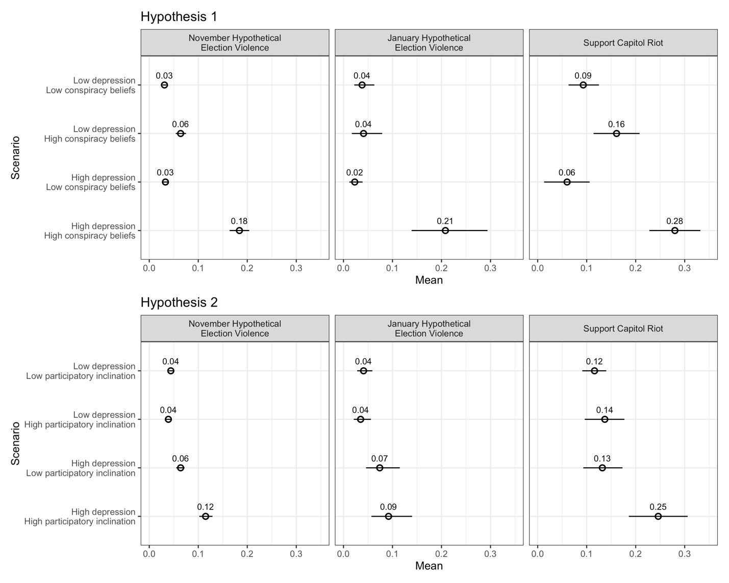

Figure 2: Relationship Between Depression, Conspiracy Beliefs, and Participatory Inclination with Support for Political Violence 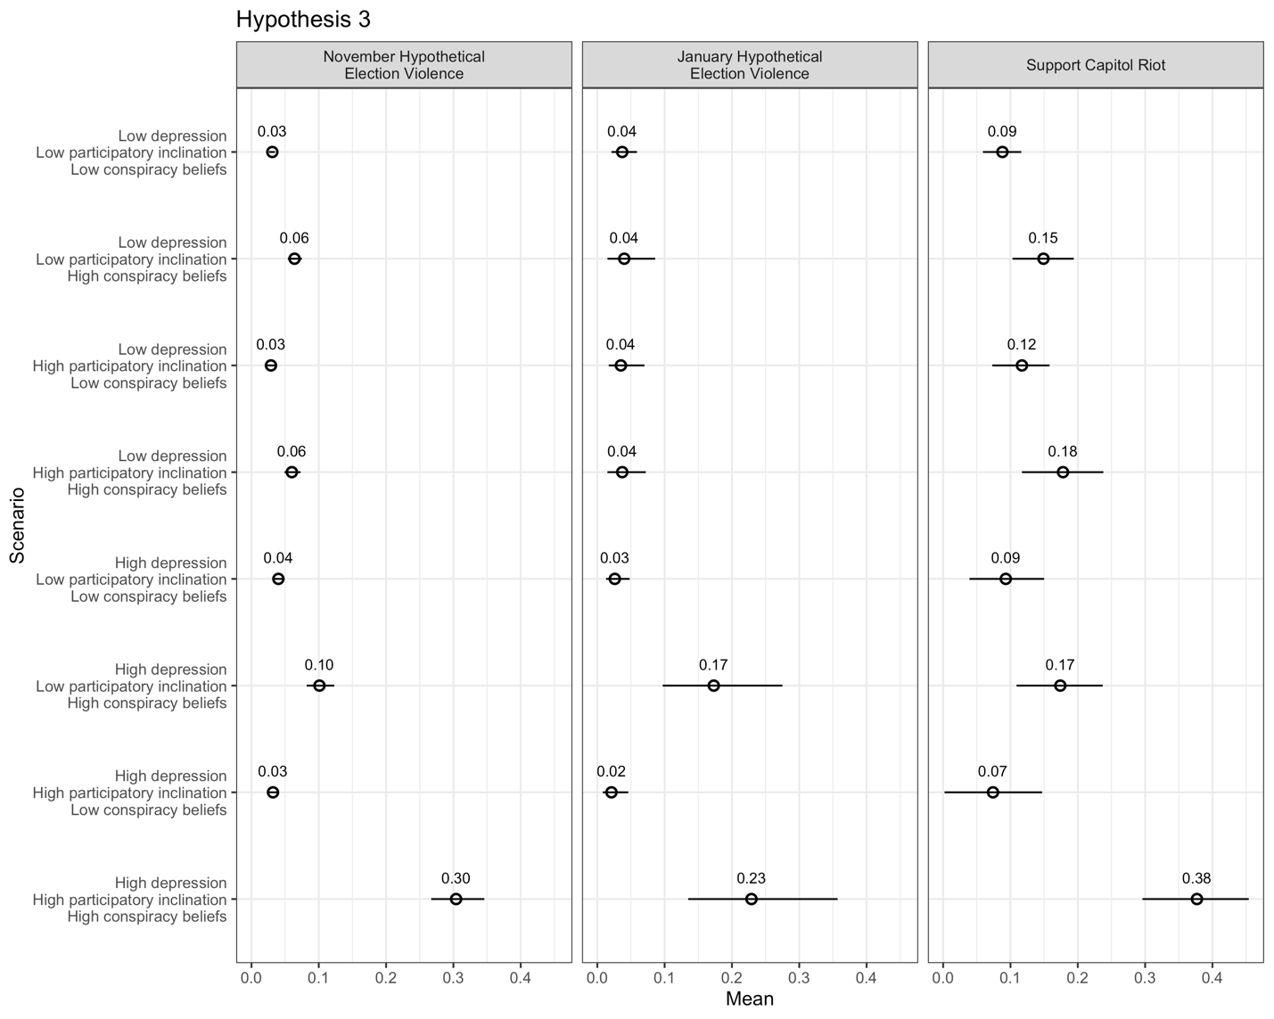

Figure 3: Subgroup Results for Democrats and Republicans for November Hypothetical Election Violence (Hypotheses 1 and 2)
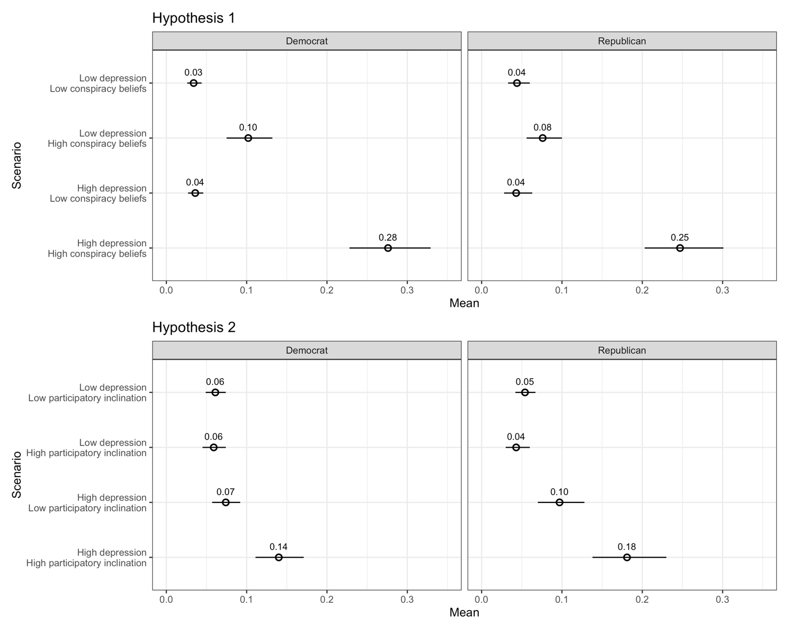

Figure 4: Subgroup Results for Democrats and Republicans for November Hypothetical Election Violence (Hypothesis 3)
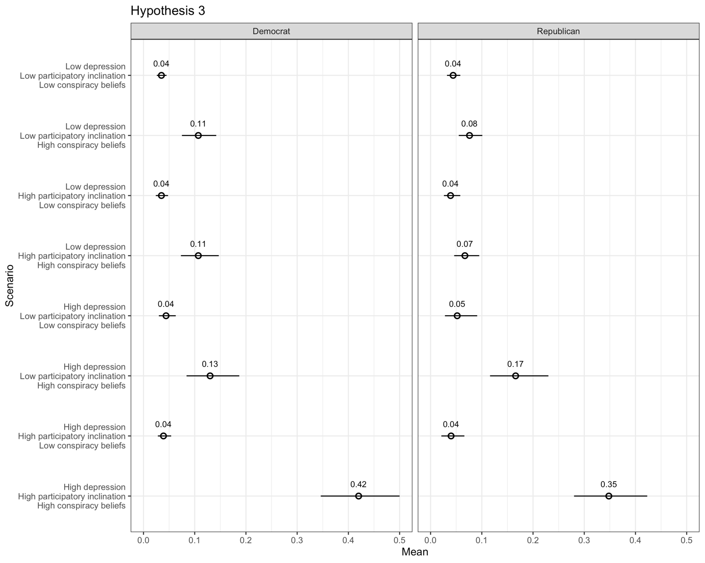

Figure 5: Subgroup Results for Trump Non-Supporters and Supporters for November Hypothetical Election Violence (Hypotheses 1 and 2)
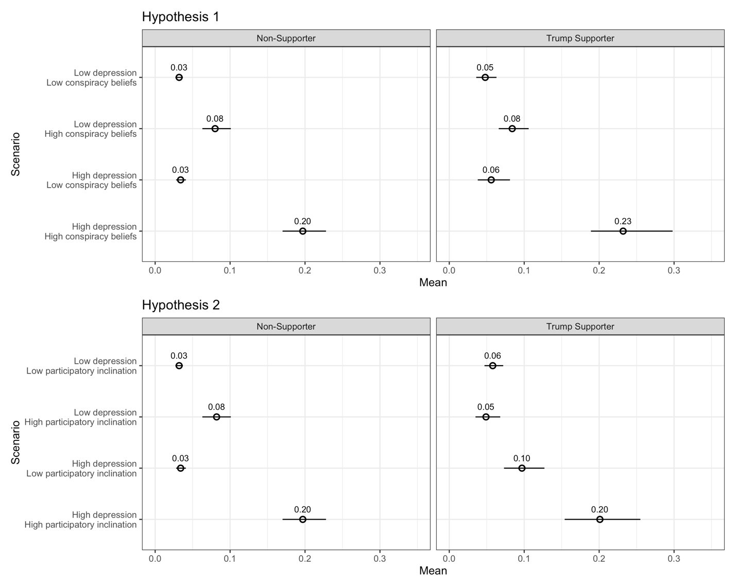

Figure 6: Subgroup Results for Trump Non-Supporters and Supporters for November Hypothetical Election Violence (Hypothesis 3)
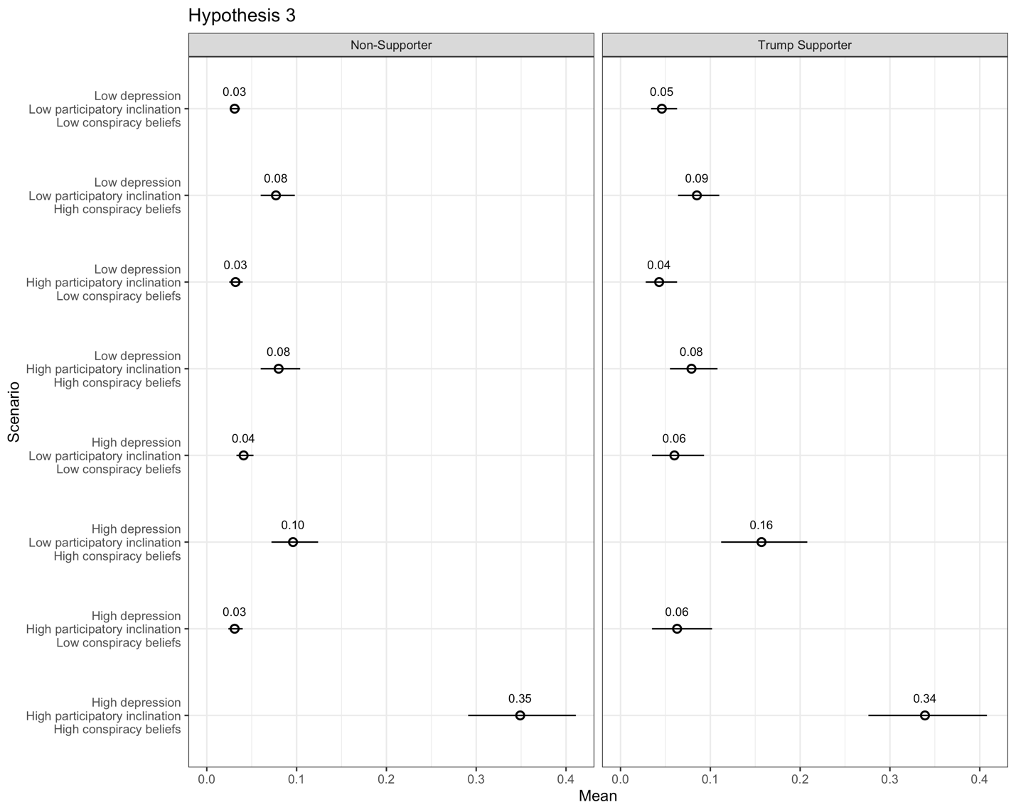

Figure 7: Subgroup Results for Men and Women for January Hypothetical Election Violence (Hypotheses 1 and 2)
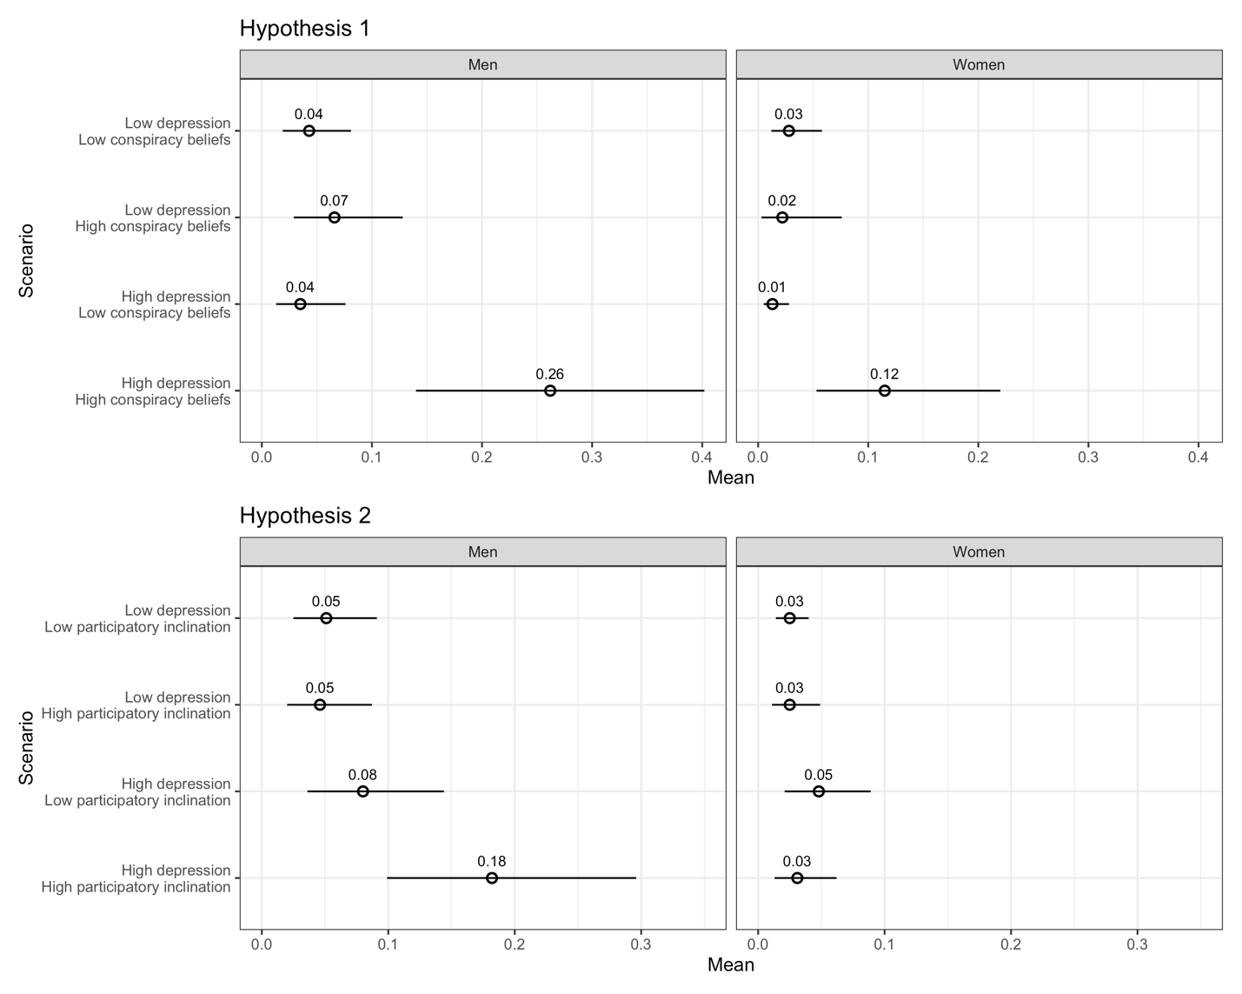

Figure 8: Subgroup Results for Men and Women for January Hypothetical Election Violence (Hypothesis 3)
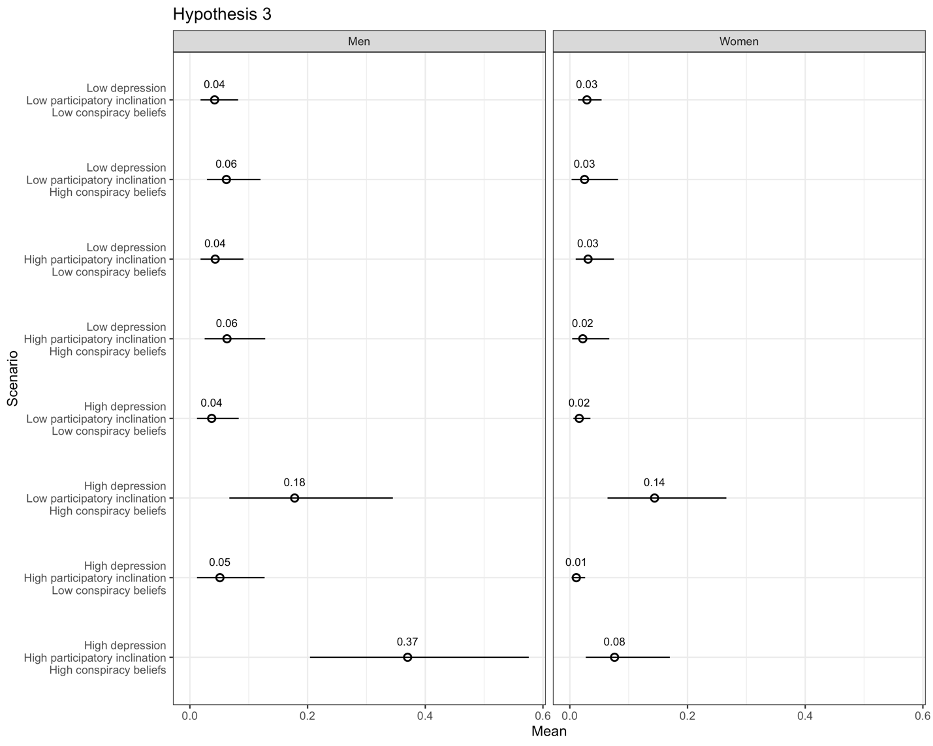

Supplemental Information (SI) for “The Political Consequences of Depression: How Conspiracy Beliefs, Participatory Inclinations, and Depression Relate to Support for Political Violence”

Table of Contents
- Survey Implementation……………………………………………………1

- Rationales for Measures…………………………………………………...1

Question Wording…………………………………………………………3

Histograms of Dependent Variables………………………………………5

Summary Statistics………………………………………………………...6

- Using Clarify………………………………………………………………7

- Main Regression Models ……………………………………………….....8

Moderate Depression Results…………………………………………….10

- Estimating Magnitudes…………………………………………………...14

- Robustness and Gender Analyses (for figures in the paper)……………...14

- Additional Party and Trump Supporter Analyses………………………...20

- Additional Gender Analyses…………………………….………………..34

- References……………………………………………….………………..40

- Survey Implementation
To minimize topical selection bias, we did not inform respondents of the purpose of the survey when they entered it, and the questions covered a broad range of topics, mostly related to public health. We filtered out inattentive and semi-automated respondents through multiple closed- and open-ended attention checks. Specifically, respondents were excluded from the survey if they failed one of two basic attention check questions (“Sometimes, people can get distracted during a survey. Just so we know you are still with us and paying attention, please select ‘never’ below” and “It is important for us to collect the best possible information about COVID-19. Just so we know you are still with us and paying attention, please select ‘always’ below,” with answer options ranging from “Never” to “Always”). We further excluded respondents who completed the 20–25-minute survey in less than 5 minutes. The rest of the respondents received a quality score based on 10 factors (items) including their percent of item non-response, straight-lining patterns (giving the same answer to a long sequence of questions), and whether they provided meaningful answers to open-ended questions. For example, respondents were asked “Other than the state you live in, in what other U.S. state do you have the most friends and family members?” with answer quality scored depending on whether their response was a state name or another location such as a city or country. A location-type answer suggested that the respondent read and addressed the question, whereas a numeric or other unrelated answer indicated a lower quality response. Those who failed more than one of the 10 items were excluded from the data used for analysis.
A distinct issue concerns our use of samples that rely upon repeat survey takers. Valentino et al. (2020) find that on-line repeat survey takers tend to be less open to experience and more politically conservative. Of relevance to us, however, is that they do not find a relationship with neuroticism, which is the personality trait in their battery tied most clearly to depression (Zinbarg et al. 2016). This vitiates concern about our sample in terms of biases around depression. Moreover, our rate of moderate or severe depression nearly perfectly matches that found in a probability panel from a similar time (Ettman et al. 2022). Our November survey ran from November 1, 2020, to November 29, 2020. Our January survey ran from January 13, 2021, to January 20, 2021.

- Rationales for Measures
In what follows, we provide detailed rationales for our key measures (some of which repeats the briefer points in the paper, in order to ensure what is written here remains self-contained).

Outcome Measures: Our interest lies in support for political violence that, as explained, can normalize extremist acts. We specifically sought to employ support for actual acts of violence, moving away from the abstracted nature of other approaches, which inherently may be problematic since it remains unclear what abstract scenarios enter people’s minds (Westwood et al. 2022). We thus included, on the January wave, measures focused on the January 6th attack. First, we asked about the insurrection itself: “Did you support or oppose the storming of the Capitol building on January 6th?' This was measured on a 5-point scale from strongly oppose to strongly support. Second, we included a 100-point “feeling thermometer'” in which higher responses indicate warmer/more positive feelings toward “The people who stormed the Capitol building on Jan 6.” We scaled these two measures by normalizing them on 0 to 1 scales and then taking the average (α = .83). We refer to this as “Support Capitol Riot.”
The Support Capitol Riot measure exploits an unprecedented opportunity to isolate support for actual violent political events in a stable democracy. That said, we also recognize the unique nature of any single event, and thus, we included two other measures that ask about hypothetical approval of violence if the election was not conducted fairly. This has the downside of being hypothetical, but it allows us to move away from the idiosyncratic events of January 6th. This is particularly the case in our November survey wave that occurred before the capital insurrection. Specifically, on our November and January survey waves, we asked respondents, “If it became clear to you that the [2020 (November wave) / 2024 (January wave)] presidential election was not conducted fairly, would you approve or disapprove of other people who reacted by…,” followed by a list of four options starting with “protesting on social media” and culminating in “using violence.” We recode the original 5-point scale (for the using violence item) into three discrete categories – disapprove, neither approve nor disapprove, and approve, – and designate it as “Hypothetical Election Violence.” The wording of this item directly relates to the finding that people express more support for extralegal violence when they have lost confidence in the legitimacy of state institutions (Cruz and Kloppe-Santamaría 2019).
Our outcomes thus measure support for political violence (by others) along distinct dimensions. Support Capitol Riot measures support for the actual attack on the U.S. Capitol / sympathy towards those who did it, November Hypothetical Election Violence measures support for responding to an unfair election with violence (prior to any such violence taking place in the real world), and January Hypothetical Election Violence measures such support following an actual manifestation of such violence on January 6th. More generally, these support for violence measures capture general tendencies towards violence not inextricably linked to partisan considerations – contrary to many canonical measures of support for violence that ask respondents if it is acceptable for a member of their party to take violent action, often against the other party (e.g., Kalmoe and Mason 2022). This is not to ignore unavoidable partisan implications of our measures, given that our questions reference an unfair election involving parties, and an insurrection that was driven by one partisan side. As discussed in the paper, we therefore control for partisanship in our models and also run robustness checks sub-setting on each party as well as support/non-support for Trump.

Measuring Depression: We measured participants’ experiences with depression via the Patient Health Questionnaire (PHQ-9), a widely used tool to screen patients for depression in primary care settings (Kroenke and Spitzer 2002, Arroll et al. 2010). The module begins by asking respondents, “Over the last two weeks, how often have you been bothered by any of the following problems?” and then presents respondents with the nine items listed in the paper’s discussion of depression (all on answered on four-point scales from “not at all” (0) to “nearly every day” (3)). The items are then summed to create an overall numeric indicator (ranging from 0 to 27). We use the scale as a continuous additive measure in models; however, when generating predicted probabilities, we simulate a respondent suffering from depression by setting the variable equal to the top decile and compare them to respondents in the lowest decile. This has an advantageous (for our purposes) substantive implication, since the top decile cutoff is 18 in the November data and 16 in the January data – both of which cross the clinical threshold for a diagnosis of “moderate to severe” depression (i.e., PHQ-9 ≥ 15) (Kroenke and Spitzer 2002). Mild to moderate depression is typically diagnosed by scores between 5 and 14. Interestingly, we find that Republicans are somewhat less depressed than Democrats; in the November survey, the average Democrat registered a score of 7.3 on the PHQ-9 battery, while the average Republican had a score of 6.0. The respective scores in the January survey are 6.9 and 5.5. This matches trends present in earlier waves of the COVID States survey data since the start of the COVID-19 pandemic (Perlis et al. 2021). As noted, the data also reveals nearly identical elevated depression rates during COVID-19 as found in probability samples at similar times (hovering around 30%; Ettman et al. 2022).

Measuring Conspiratorial Beliefs: To measure conspiratorial beliefs, we presented respondents with 12 statements about politics and the pandemic – 10 of them false – and counted the number about which they had incorrect beliefs (relative to the best available information at the time). Nine of the statements focused on COVID-19 (e.g., “There is a cure for coronavirus that is being withheld from the US public”), two were about politics with one being explicitly about the election and one being about national security (i.e., if Osama bin Laden is alive). The full list of items is available below. We focused on COVID-19 and the election since our outcome variables involved support for contemporary violence (around the election and January 6th). Thus, our basic conspiracy construct was belief in conspiracies at that time (i.e., our theory posits these beliefs provide a sense of control and target against whom violent action is justifiable – with the target revolving around the contemporary election and January 6th). In short, they matched our outcome variables and specificity in our outcome measures is crucial when measuring support for violence (Westwood et al. 2022). That said, we are confident that our results would generalize had we used distinct items. There is strong evidence that conspiracy beliefs on one subset of measures generalizes across a broader domain of conspiracy beliefs (Sutton and Douglas 2020: 118-119, Baum and Ognyanova 2022). While we treat conspiratorial beliefs as continuous in our regressions, when generating predicted probabilities, as with depression, we simulate a conspiratorial respondent by setting the variable equal to the top decile and compare them to respondents in the lowest decile. When we re-run all of our simulations using the 25th and 75th percentiles, and the results remain robust. Conspiratorial beliefs correlate with Trump support and being a Republican. As explained, our predictions are nonetheless orthogonal to partisanship or candidate support, and we tested this in multiple ways.

Measuring Participatory Inclination: Our participatory inclination concept refers to a tendency to take a political action. We measure it with a question that asked the respondents whether they had participated in at least one of six political actions in the past six months. The activities included volunteering for a candidate, party or political organization; attending a rally or protest; calling or writing an elected official; attending a town hall held by an elected official; posting about politics on social media; or making a political donation. Each of these six actions are individually not particularly common; for example, according to the 2020 American National Election Studies data, only 3% worked for a party or candidate, 6% attended a political meeting, and 19% gave money to help a campaign. A study from the Pew Research Center, in turn, shows 70% of social media users never or rarely post about political or social issues (McClain 2021). It is not surprising then that, in our data, by far the largest threshold distinction is between “no” political activity and engaging in “any” of the six political activities (around 30% of respondents in both the November and January surveys). Doing any of these activities suggests a participatory inclination; we thus coded our variable as 1 if the respondent participated in any activity and 0 if they did not. If the person has taken action in the past, it suggests they may feel empowered to do so again (a la regaining control, as discussed).

Question Wording
Support Capitol Riot. This outcome variable is based on the next two questions:

Support Attack: “Did you support or oppose the storming of the Capitol building on January 6th?” Strongly support; Somewhat support; Neither support nor oppose; Somewhat oppose; Strongly oppose
We grouped responses into three discrete categories: support, neither support nor oppose, and oppose.

Sympathize Stormers: “We’d like to get your feelings towards different groups on a scale of 0 to 100, which we call a “feeling thermometer.” On this feeling thermometer scale, ratings between 0 and 49 degrees mean that you feel unfavorable and cold (with 0 being the most unfavorable/coldest). Ratings between 51 and 100 degrees mean that you feel favorable and warm (with 100 being the most favorable/warmest). A rating of 50 means you have no feelings one way or the other. How would you rate each of the following groups?” .…The people who stormed the Capitol building on Jan 6… (Respondents rated a total of 16 groups.)
We created the final Support Capitol Riot variable as follows. We first normalized both individual variables to 0-1 intervals. We then added them together and took the average of the combined scale elements, resulting in a summary 0-1 interval scale. (The alpha reliability score for the two variables is .83, indicating that it is appropriate to combine them into a scale.)

Hypothetical Election Violence: “If it became clear to you that the [2020 / 2024] presidential election was not conducted fairly, would you approve or disapprove of other people who reacted by…” Protesting on social media; Joining an in-person protest; Violating laws but without violence (e.g., defacing public property, trespassing); Using violence
Response categories were “strongly approve,” “somewhat approve,” “neither approve nor disapprove,” “somewhat disapprove,” and “strongly disapprove.” Using only the final item in the list (“using violence”) we created the Hypothetical Election Violence outcome by grouping responses into three discrete categories: approve, neither approve nor disapprove, and disapprove. This question appeared in both the November 2020 and January 2021 survey waves; hence the variable labels Hypothetical Election Violence (November) and Hypothetical Election Violence (January).

Depression: “Over the last two weeks, how often have you been bothered by the following problems?” Little interest or pleasure in doing things; Feeling down, depressed, or hopeless; Trouble falling or staying asleep, or sleeping too much; Feeling tired or having little energy; Poor appetite or overeating; Feeling bad about yourself - or that you are a failure or have let yourself or your family down; Trouble concentrating on things, such as reading the newspaper or watching television; Moving or speaking so slowly that other people could have noticed – or so fidgety or restless that you have been moving a lot more than usual; Thoughts that you would be better off dead, or thoughts of hurting yourself in some way
Responses are coded as 0 (not at all), 1 (several days), 2 (more than half the days), and 3 (nearly every day).

Participatory Inclination: “Which of the following, if any, have you done in the last 6 months? (Please select all that apply)” Volunteered for a candidate, political party, or other political organization; Attended a rally or protest; Called or wrote to an elected official; Attended a town hall held by an elected official; Posted about politics on social media; Made a donation to a candidate, party, or other political organization
Respondents who selected at least one item were coded 1; otherwise, 0.

Conspiratorial Beliefs: “Below are some statements about the current health crisis and politics. To the best of your knowledge, are those statements accurate or inaccurate?” Only people older than 60 are at risk for coronavirus; Coronavirus was created as a weapon in a Chinese lab; Humans originally got coronavirus by eating bats; President Trump has declared a national emergency; There is currently no approved vaccine against the coronavirus; There is a cure for coronavirus that is being withheld from the U.S. public; Flu vaccines increase the chance of getting coronavirus; Hydroxychloroquine is an effective treatment for coronavirus; Wearing a face mask increases the chance of getting coronavirus; Osama bin Laden is still alive today; Thousands of election ballots were found in dumpsters; Joe Biden used his post as Vice President to gain profit for his family
Participants were asked to indicate whether each item was “accurate”, “inaccurate”, or that they “don’t know”. Each inaccurate item is coded 1 for a response of “accurate” and 0 otherwise. The two claims that were accurate as of November 2020 (Trump’s national emergency declaration and the lack of an approved vaccine) were reverse coded with 1 for “inaccurate” and 0 otherwise. These scores were then summed to create the conspiratorial beliefs variable that we treat as linear.

Trump Supporter: This variable was generated from two questions. Those who indicated they had voted were asked, “Which candidate did you vote for in the 2020 U.S. presidential election?” Those who said they had not voted were asked, “Which candidate do you support in the 2020 U.S. presidential election?” Joe Biden (Democrat); Donald Trump (Republican); Another candidate: ______; I did not vote (shown to those who said they voted (as a check)); Not sure (shown to those who said they voted); I do not support any candidate (shown to those who said they did not vote)
In both cases. respondents were coded as 1 if they chose “Donald Trump (Republican)” and 0 otherwise.

Party: “Generally speaking, do you think of yourself as a…” Democrat; Republican; Independent; Other
We treat “Other” as the reference category.

Ideology: “In general, do you think of yourself as…” Extremely liberal; Liberal; Slightly liberal; Moderate, middle of the road; Slightly conservative; Conservative; Extremely conservative
We treat this 7-point scale as linear.

Political Interest: “How interested are you in US politics and government?” Not at all interested; Not very interested; Somewhat interested; Very interested; Extremely interested
We treat this 5-point scale as linear.

Election Confidence: “How confident are you in the fairness of the 2020 presidential election?” Not at all confident; Not very confident; Mostly confident; Very confident;
We treat this 4-point scale as linear.

Education: “What is the highest level of education you have completed?” Grade 9 or less; Some high school, did not graduate; High school graduate (diploma, GED, or equivalent); Some college, no degree; Associate degree (AA, AS); Bachelor’s degree (BA, BS); Graduate degree (master’s, PhD, or professional degree beyond bachelor’s)
We treat this 7-point scale as linear.
Age: “What is your current age?” Responses range from 18 (18) to 110 (110).
Facebook Election News: “In the last 24 hours, did you get any news or information related to the 2020 U.S. election from Facebook (website or app)?”
This variable is only fully available for our January data/analyses.

Race: “What racial or ethnic group best describes you? (Please select all that apply).” Asian or Asian-American; Black or African-American; Hispanic or Latino; Native American or Alaska Native; Pacific Islander or Native Hawaiian; White or Caucasian Other: _______
Responses are transformed into four dummy variables for Black, White, Hispanic, and Asian American. All other responses (pooled) serve as a reference category.

Income: “My household income is approximately ______ per year”: Under 15K; 15K to under 25K; 25K to under 35K; 35K to under 50K; 50K to under 75K; 75K to under 100K; 100K to under 150K; 150K to under 200K; Over 200K

Histograms of Dependent Variables
Figure A.1. Histograms

Summary Statistics
​​Table A.1.: Summary Statistics: Respondents who completed both the November and January surveys
Variable | Mean | St. Dev. | Min | Max
Depression (Full Scale) | 6.19 | 0.23 | 0 | 27
Conspiratorial Beliefs | 0.19 | 0.005 | 0 | 1
Facebook Election News | 0.479 | 0.016 | 0 | 1
Support Capitol Riot | .144 | 0.241 | 0 | 1
Election Confidence | 2.85 | 0.037 | 1 | 4
Hypothetical Election  Violence (January) | 0.15 | 0.01 | 0 | 1
Political Interest | 3.3 | 0.042 | 1 | 5
Participatory Inclination | 0.297 | 0.014 | 0 | 1
Republican | 0.295 | 0.014 | 0 | 1
Democrat | 0.388 | 0.016 | 0 | 1
Independent | 0.276 | 0.014 | 0 | 1
White | 0.629 | 0.016 | 0 | 1
Black | 0.122 | 0.01 | 0 | 1
Hispanic | 0.157 | 0.014 | 0 | 1
Asian American | 0.063 | 0.007 | 0 | 1
Income | 3.94 | 0.066 | 1 | 10
Ideology | 4.03 | 0.052 | 1 | 7
Education | 3.01 | 0.043 | 1 | 7
Age | 48.53 | 0.653 | 18 | 99
Male | 0.477 | 0.016 | 0 | 1
Trump Supporter | 0.337 | 0.015 | 0 | 1

Table A.2.: Respondents who completed the November survey
Variable | Mean | St. Dev. | Min | Max
Depression (Full Scale) | 6.86 | 0.064 | 0 | 27
Conspiratorial Beliefs | 0.205 | 0.002 | 0 | 1*
Election Confidence | 2.8 | 0.01 | 1 | 4
Hypothetical Election  Violence (November) | 0.134 | 0.003 | 0 | 1
Political Interest | 3.36 | 0.012 | 1 | 5
Participatory Inclination | 0.357 | 0.004 | 0 | 1
Republican | 0.294 | 0.004 | 0 | 1
Democrat | 0.379 | 0.005 | 0 | 1
Independent | 0.276 | 0.004 | 0 | 1
White | 0.644 | 0.005 | 0 | 1
Black | 0.124 | 0.003 | 0 | 1
Hispanic | 0.149 | 0.004 | 0 | 1
Asian American | 0.061 | 0.002 | 0 | 1
Income | 4.03 | 0.02 | 1 | 10
Ideology | 4 | 0.015 | 1 | 7
Education | 3.01 | 0.012 | 1 | 7
Age | 47.51 | 0.177 | 18 | 99
Male | 0.472 | 0.005 | 0 | 1
Trump Supporter | 0.36 | 0.004 | 0 | 1
*In the data, the maximum is 1.09 due to dividing by 11 instead of 12 when re-scaling from 0 to 12 to a 0 to 1 scale. This has no effect on the results reported.
- Using Clarify
We focus in the main paper on the key interactions, comparing the statistical significance of the differences in substantive effects at different values of the key causal variables. In several instances we find statistically significant substantive differences on the key interactions even where the coefficients on one or more key variables or interactions terms do not reach standard levels of statistical significance. This is common in interactive relationships, where the quantities of interest are not the coefficients themselves, but the first differences in predicted probabilities or expected values on the outcome variables (in this case, support for violence) as the key causal variables (here, depression, conspiracy beliefs, and participatory inclination) vary in combination (Tomz et al. 2003). As Tomz et al. (2003: 19) put it:
Is it ok if some of my explanatory variables are statistically insignificant? Yes. Clarify computes quantities of interest based on all estimated coefficients, regardless of their level of statistical significance. This is not problematic because the true quantities of interest are usually the predicted values, expected values, and first differences, not the coefficients themselves. It is usually better to focus on the confidence intervals Clarify reports for each quantity it computes than the standard errors of coefficients. Moreover, even coefficients that are not statistically significant can provide important information: after all, a coefficient that is not significantly different from zero will probably [be] significantly different from almost all other numbers.

- Main Regression Models

Table A.3. Support for Violence
 |  | Support Capital Riot |  |  | Hypothetical Election Violence  (November) |  |  |  |  | Hypothetical Election Violence  (January)
 |  | (1) | (2) | (3) |  | (4) | (5) | (6) | (7) |  | (8) | (9)
Depression |  | -0.00200 | 0.000986 | 0.000323 |  | 0.00478 | 0.0209*** | 0.0145^ | -0.0315 |  | 0.0376* | -0.0239
 |  | (0.00177) | (0.00139) | (0.00209) |  | (0.00622) | (0.00512) | (0.00744) | (0.0255) |  | (0.0168) | (0.0269)
Conspiracy Beliefs |  | 0.157* | 0.324*** | 0.144^ |  | 1.719*** | 3.014*** | 1.719*** | 0.0920 |  | 3.061*** | 0.0367
 |  | (0.0754) | (0.0637) | (0.0738) |  | (0.277) | (0.156) | (0.284) | (1.424) |  | (0.602) | (1.435)
Participatory |  | 0.0568** | 0.0210 | 0.0296 |  | 0.257*** | -0.140 | -0.0722 | 0.0101 |  | -0.186 | -0.0758
Inclination |  | (0.0179) | (0.0223) | (0.0214) |  | (0.0575) | (0.0880) | (0.0898) | (0.218) |  | (0.277) | (0.298)
Democrat |  | -0.0317 | -0.0341 | -0.0245 |  | -0.237* | -0.247* | -0.240* | 0.726 |  | 0.621 | 0.749
 |  | (0.0604) | (0.0579) | (0.0579) |  | (0.117) | (0.116) | (0.114) | (0.507) |  | (0.474) | (0.498)
Republican |  | 0.0258 | 0.0239 | 0.0241 |  | -0.183 | -0.187 | -0.209 | 0.677 |  | 0.617 | 0.666
 |  | (0.0665) | (0.0628) | (0.0624) |  | (0.134) | (0.133) | (0.132) | (0.548) |  | (0.509) | (0.530)
Independent |  | 0.0167 | 0.0164 | 0.0202 |  | -0.308** | -0.309** | -0.319** | 0.804 |  | 0.705 | 0.812^
 |  | (0.0610) | (0.0580) | (0.0578) |  | (0.115) | (0.114) | (0.112) | (0.492) |  | (0.452) | (0.475)
Ideology |  | 0.00638 | 0.00597 | 0.00584 |  | -0.104*** | -0.104*** | -0.110*** | -0.0333 |  | -0.0406 | -0.0326
 |  | (0.00646) | (0.00648) | (0.00626) |  | (0.0210) | (0.0210) | (0.0214) | (0.0700) |  | (0.0703) | (0.0701)
Political Interest |  | -0.00154 | -0.00176 | -0.000290 |  | -0.117*** | -0.123*** | -0.115*** | -0.235** |  | -0.232** | -0.228**
 |  | (0.00657) | (0.00673) | (0.00653) |  | (0.0269) | (0.0267) | (0.0270) | (0.0883) |  | (0.0828) | (0.0880)
Black |  | 0.0485 | 0.0471 | 0.0445 |  | 0.683*** | 0.696*** | 0.663*** | -0.536 |  | -0.483 | -0.548
 |  | (0.0600) | (0.0601) | (0.0612) |  | (0.153) | (0.152) | (0.150) | (0.410) |  | (0.423) | (0.410)
White |  | 0.00601 | 0.00413 | 0.00508 |  | 0.127 | 0.137 | 0.112 | -0.898* |  | -0.916* | -0.901*
 |  | (0.0578) | (0.0579) | (0.0592) |  | (0.142) | (0.141) | (0.139) | (0.391) |  | (0.405) | (0.390)
Asian |  | 0.0373 | 0.0356 | 0.0327 |  | 0.412* | 0.410* | 0.407* | -0.711 |  | -0.704 | -0.729
 |  | (0.0640) | (0.0639) | (0.0647) |  | (0.179) | (0.179) | (0.177) | (0.460) |  | (0.470) | (0.461)
Hispanic |  | 0.0490 | 0.0447 | 0.0494 |  | 0.478** | 0.475** | 0.465** | -1.067* |  | -1.059* | -1.064*
 |  | (0.0629) | (0.0628) | (0.0642) |  | (0.157) | (0.155) | (0.153) | (0.441) |  | (0.453) | (0.442)
Income |  | -0.00160 | -0.00127 | -0.00186 |  | 0.0114 | 0.0142 | 0.00792 | -0.0134 |  | -0.00519 | -0.0146
 |  | (0.00335) | (0.00340) | (0.00333) |  | (0.0131) | (0.0131) | (0.0132) | (0.0426) |  | (0.0432) | (0.0428)
Education |  | -0.00237 | -0.00214 | -0.00438 |  | 0.0128 | 0.0141 | -0.00215 | 0.0421 |  | 0.0537 | 0.0351
 |  | (0.00672) | (0.00677) | (0.00663) |  | (0.0284) | (0.0286) | (0.0287) | (0.0879) |  | (0.0919) | (0.0895)
Age |  | -0.00264*** | -0.00259*** | -0.00258*** |  | -0.0193*** | -0.0188*** | -0.0188*** | -0.0395*** |  | -0.0389*** | -0.0391***
 |  | (0.000512) | (0.000509) | (0.000499) |  | (0.00186) | (0.00187) | (0.00188) | (0.00591) |  | (0.00598) | (0.00586)
Facebook Election |  | 0.0290* | 0.0276^ | 0.0255^ |  |  |  |  | 0.885*** |  | 0.862*** | 0.875***
News |  | (0.0145) | (0.0144) | (0.0142) |  |  |  |  | (0.178) |  | (0.178) | (0.178)
Election Confidence |  | -0.0108 | -0.00880 | -0.0154^ |  | 0.0782* | 0.0903** | 0.0509 | -0.0526 |  | -0.0364 | -0.0648
 |  | (0.00818) | (0.00853) | (0.00814) |  | (0.0324) | (0.0321) | (0.0328) | (0.112) |  | (0.110) | (0.113)
Trump Supporter |  | 0.0662** | 0.0654** | 0.0742** |  | -0.223* | -0.243* | -0.219* | -0.191 |  | -0.227 | -0.171
 |  | (0.0243) | (0.0243) | (0.0231) |  | (0.0962) | (0.0947) | (0.0953) | (0.300) |  | (0.308) | (0.303)
Male |  | 0.0365** | 0.0409** | 0.0343** |  | 0.634*** | 0.646*** | 0.626*** | 0.660*** |  | 0.701*** | 0.644***
 |  | (0.0134) | (0.0135) | (0.0132) |  | (0.0523) | (0.0521) | (0.0525) | (0.178) |  | (0.175) | (0.177)
Depression X |  |  | 0.00569* | -0.00308 |  |  | 0.0439*** | -0.00864 |  |  | 0.0279 | -0.0119
Participatory Inclination |  |  | (0.00272) | (0.00332) |  |  | (0.00742) | (0.00945) |  |  | (0.0272) | (0.0371)
Depression X |  | 0.0226*** |  | 0.00312 |  | 0.137*** |  | 0.0289 | 0.354** |  |  | 0.304*
Conspiracy Beliefs |  | (0.00685) |  | (0.00878) |  | (0.0208) |  | (0.0270) | (0.118) |  |  | (0.127)
Depression X |  |  |  | 0.0333** |  |  |  | 0.196*** |  |  |  | 0.0937
Conspiracy Beliefs X Participatory Inclination |  |  |  | (0.0105) |  |  |  | (0.0262) |  |  |  | (0.110)
Constant 1 |  | 0.158^ | 0.129 | 0.179* |  | 1.122*** | 1.345*** | 0.860*** | -0.453 |  | 0.137 | -0.501
 |  | (0.0836) | (0.0835) | (0.0835) |  | (0.233) | (0.226) | (0.232) | (0.736) |  | (0.737) | (0.728)
Constant 2 |  |  |  |  |  | 2.379*** | 2.595*** | 2.138*** | 0.974 |  | 1.507* | 0.929
 |  |  |  |  |  | (0.230) | (0.224) | (0.229) | (0.737) |  | (0.742) | (0.731)
Observations |  | 1,765 | 1,765 | 1,765 |  | 18,879 | 18,879 | 18,879 | 1,769 |  | 1,769 | 1,769
R-squared |  | 0.249 | 0.242 | 0.264
Robust standard errors in parentheses
*** p<0.001, ** p<0.01, * p<0.05, ^ p<0.10 for two-tailed tests.

Moderate Depression Results
Figure A.2. Test for Moderate Depression – Test of Hypotheses 1 and 2
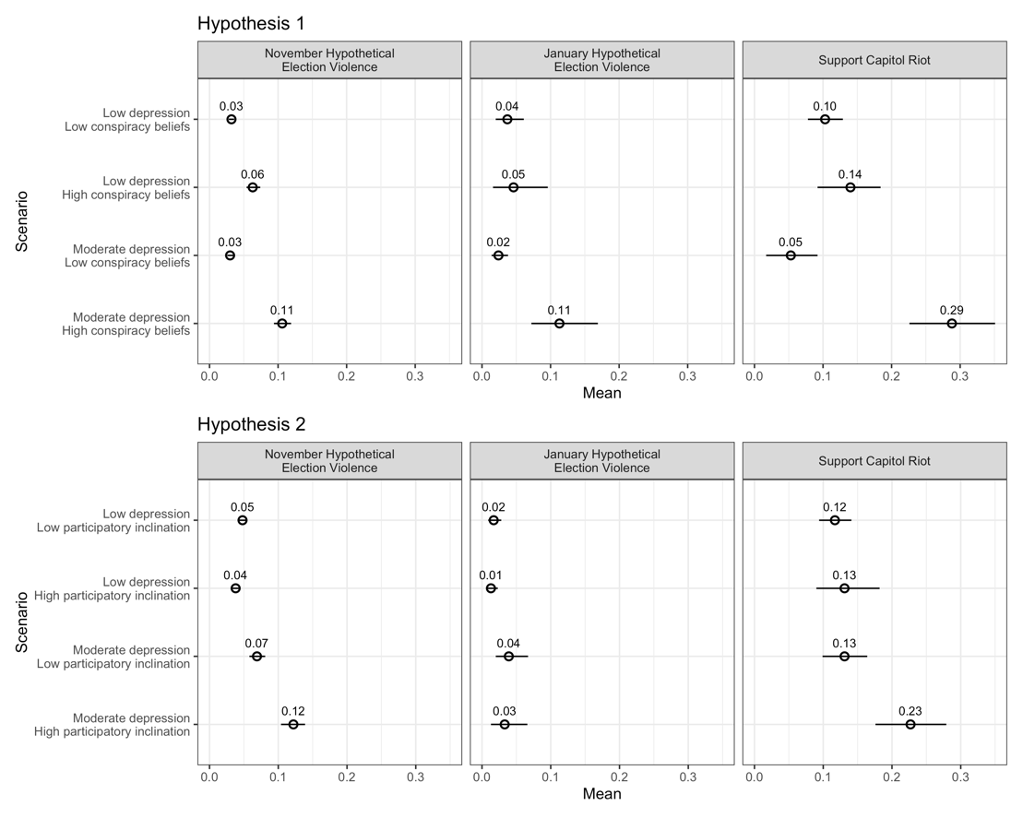
Figure A.3. Test for Moderate Depression – Test of Hypothesis 3
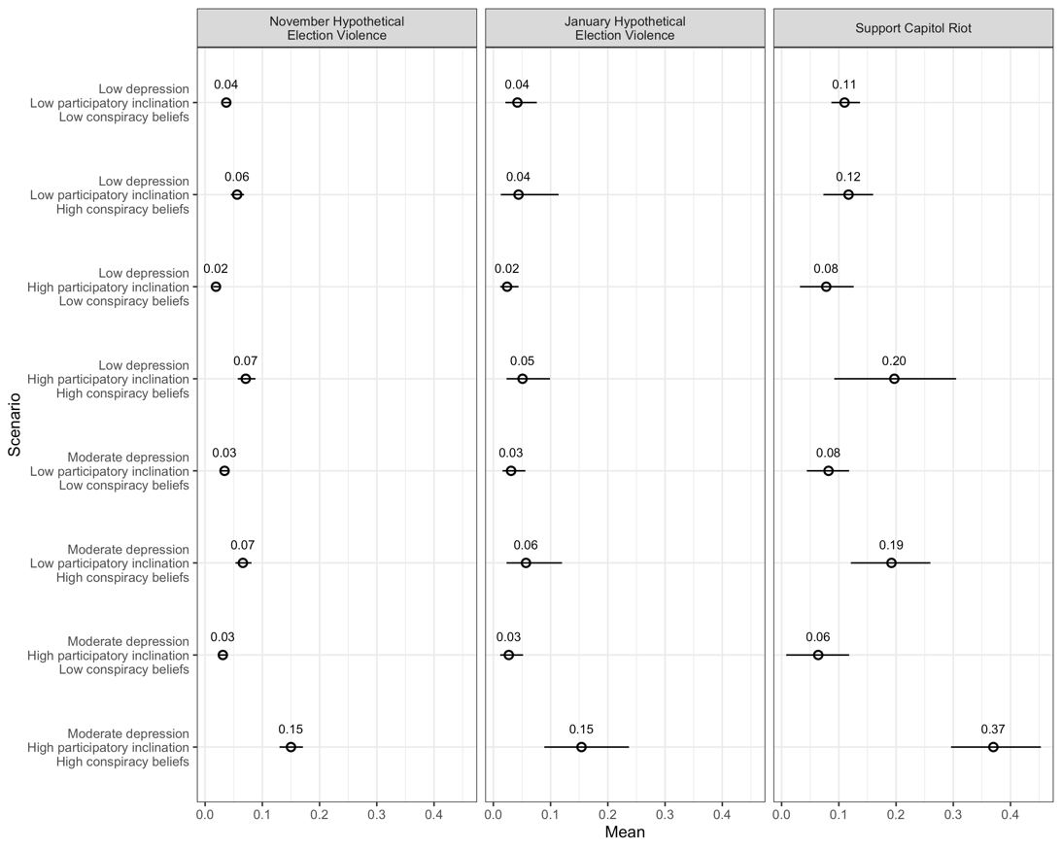

Table A.4.: Test for Moderate Depression
 | Support Capitol Riot |  |  | Hypothetical Election Violence  (November) |  |  | Hypothetical Election Violence  (January)
 | (1) | (2) | (3) | (4) | (5) | (6) | (7) | (8) | (9)
Moderate | -0.0489* | 0.0138 | -0.0292 | -0.0592 | 0.0356 | -0.0922 | -0.428 | 0.00222 | -0.311
Depression | (0.0196) | (0.0167) | (0.0223) | (0.101) | (0.0808) | (0.126) | (0.364) | (0.252) | (0.447)
Severe Depression | -0.0330 | 0.00518 | -0.0170 | -0.00328 | 0.385*** | 0.0125 | -0.423 | 0.844* | -0.540
 | (0.0381) | (0.0309) | (0.0493) | (0.116) | (0.0974) | (0.146) | (0.469) | (0.328) | (0.606)
Participatory | 0.0533** |  | -0.0337 | 0.260*** |  | -0.688*** | 0.0114 |  | -0.623
Inclination | (0.0177) |  | (0.0263) | (0.0575) |  | (0.166) | (0.216) |  | (0.473)
Conspiracy Beliefs |  | 0.323*** | 0.0156 |  | 3.035*** | 0.998** |  | 2.971*** | -0.156
 |  | (0.0623) | (0.0699) |  | (0.155) | (0.384) |  | (0.605) | (2.055)
Ideology | 0.00673 | 0.00616 | 0.00654 | -0.105*** | -0.103*** | -0.111*** | -0.0332 | -0.0468 | -0.0312
 | (0.00621) | (0.00635) | (0.00599) | (0.0210) | (0.0210) | (0.0213) | (0.0708) | (0.0708) | (0.0700)
Political Interest | -0.000924 | -0.00144 | -1.88e-05 | -0.116*** | -0.119*** | -0.110*** | -0.233** | -0.226** | -0.231*
 | (0.00649) | (0.00676) | (0.00641) | (0.0269) | (0.0266) | (0.0270) | (0.0871) | (0.0835) | (0.0906)
Black | 0.0535 | 0.0468 | 0.0481 | 0.673*** | 0.687*** | 0.659*** | -0.546 | -0.541 | -0.582
 | (0.0614) | (0.0600) | (0.0626) | (0.151) | (0.150) | (0.150) | (0.418) | (0.413) | (0.411)
White | 0.00923 | 0.00457 | 0.00675 | 0.122 | 0.131 | 0.115 | -0.921* | -0.984* | -0.980*
 | (0.0593) | (0.0577) | (0.0607) | (0.140) | (0.139) | (0.139) | (0.401) | (0.399) | (0.392)
Asian | 0.0335 | 0.0342 | 0.0243 | 0.398* | 0.399* | 0.402* | -0.784 | -0.772 | -0.872^
 | (0.0642) | (0.0635) | (0.0650) | (0.178) | (0.178) | (0.177) | (0.483) | (0.475) | (0.500)
Hispanic | 0.0519 | 0.0457 | 0.0502 | 0.469** | 0.467** | 0.456** | -1.090* | -1.093* | -1.117*
 | (0.0642) | (0.0625) | (0.0655) | (0.155) | (0.154) | (0.153) | (0.449) | (0.443) | (0.441)
Income | -0.00193 | -0.00144 | -0.00218 | 0.0100 | 0.0130 | 0.00618 | -0.0171 | -0.0111 | -0.0243
 | (0.00334) | (0.00339) | (0.00329) | (0.0131) | (0.0131) | (0.0132) | (0.0418) | (0.0420) | (0.0410)
Age | -0.00263*** | -0.00261*** | -0.00252*** | -0.0200*** | -0.0193*** | -0.0192*** | -0.0405*** | -0.0403*** | -0.0394***
 | (0.000514) | (0.000511) | (0.000496) | (0.00186) | (0.00187) | (0.00188) | (0.00586) | (0.00589) | (0.00577)
Male | 0.0354** | 0.0420** | 0.0346** | 0.629*** | 0.640*** | 0.618*** | 0.671*** | 0.723*** | 0.660***
 | (0.0132) | (0.0134) | (0.0129) | (0.0523) | (0.0521) | (0.0526) | (0.178) | (0.173) | (0.176)
Education | -0.00240 | -0.00235 | -0.00377 | 0.00899 | 0.0111 | -0.00563 | 0.0477 | 0.0592 | 0.0554
 | (0.00667) | (0.00671) | (0.00650) | (0.0284) | (0.0286) | (0.0289) | (0.0884) | (0.0919) | (0.0902)
Election Confidence | -0.0133^ | -0.00946 | -0.0175* | 0.0795* | 0.0911** | 0.0545^ | -0.0598 | -0.0486 | -0.0710
 | (0.00784) | (0.00838) | (0.00774) | (0.0324) | (0.0320) | (0.0327) | (0.110) | (0.109) | (0.112)
Trump Supporter | 0.0649** | 0.0650** | 0.0727** | -0.225* | -0.254** | -0.227* | -0.213 | -0.236 | -0.173
 | (0.0239) | (0.0242) | (0.0228) | (0.0961) | (0.0945) | (0.0957) | (0.310) | (0.308) | (0.308)
Democrat | -0.0340 | -0.0342 | -0.0219 | -0.247* | -0.258* | -0.228* | 0.669 | 0.614 | 0.825
 | (0.0602) | (0.0574) | (0.0585) | (0.116) | (0.116) | (0.114) | (0.512) | (0.485) | (0.528)
Republican | 0.0167 | 0.0220 | 0.0165 | -0.200 | -0.195 | -0.201 | 0.604 | 0.647 | 0.718
 | (0.0658) | (0.0618) | (0.0622) | (0.133) | (0.132) | (0.132) | (0.554) | (0.526) | (0.569)
Independent | 0.0148 | 0.0150 | 0.0200 | -0.321** | -0.320** | -0.308** | 0.755 | 0.687 | 0.864^
 | (0.0605) | (0.0574) | (0.0581) | (0.115) | (0.114) | (0.112) | (0.493) | (0.465) | (0.505)
Facebook Election | 0.0302* | 0.0278^ | 0.0282* |  |  |  | 0.900*** | 0.894*** | 0.914***
News | (0.0143) | (0.0145) | (0.0142) |  |  |  | (0.177) | (0.179) | (0.178)
Mild Depression X | 0.0933 |  |  | 1.682*** |  |  | 0.420
Conspiracy Beliefs | (0.0699) |  |  | (0.304) |  |  | (1.515)
Mild Depression X |  | 0.0141 |  |  | -0.238* |  |  | -0.302
Participatory Inclination |  | (0.0227) |  |  | (0.102) |  |  | (0.298)
Moderate | 0.558*** |  | 0.245* | 3.165*** |  | 0.642 | 3.934*** |  | 1.592
Depression X Conspiracy Beliefs | (0.0951) |  | (0.125) | (0.234) |  | (0.546) | (0.846) |  | (2.436)
Severe Depression | 0.446*** |  | 0.132 | 4.586*** |  | 1.833** | 6.006*** |  | 6.861*
X Conspiracy Beliefs | (0.135) |  | (0.209) | (0.267) |  | (0.610) | (1.130) |  | (2.771)
Moderate |  | 0.0959** | 0.0163 |  | 0.450*** | 0.598** |  | 0.501^ | 0.424
Depression X Participatory Inclination |  | (0.0293) | (0.0420) |  | (0.0841) | (0.213) |  | (0.300) | (0.660)
Severe Depression |  | 0.112* | 0.0346 |  | 0.628*** | 0.484* |  | -0.219 | 0.258
X Participatory Inclination |  | (0.0520) | (0.0782) |  | (0.110) | (0.238) |  | (0.444) | (0.899)
Mild Depression X |  |  | 0.271 |  |  | 2.227*** |  |  | 2.068
Participatory Inclination X Conspiracy Beliefs |  |  | (0.178) |  |  | (0.580) |  |  | (2.416)
Moderate |  |  | 0.469** |  |  | 2.403*** |  |  | 3.183^
Depression X Participatory Inclination X Conspiracy Beliefs |  |  | (0.162) |  |  | (0.488) |  |  | (1.823)
Severe Depression |  |  | 0.466^ |  |  | 3.081*** |  |  | -0.621
X Participatory Inclination X Conspiracy Beliefs |  |  | (0.267) |  |  | (0.589) |  |  | (2.205)
Constant 1 | 0.174* | 0.133 | 0.200* | 1.007*** | 1.236*** | 0.649** | -0.576 | -0.135 | -0.608
 | (0.0843) | (0.0830) | (0.0850) | (0.230) | (0.223) | (0.232) | (0.746) | (0.731) | (0.763)
Constant 2 |  |  |  | 2.263*** | 2.484*** | 1.928*** | 0.830 | 1.234^ | 0.822
 |  |  |  | (0.227) | (0.221) | (0.228) | (0.749) | (0.736) | (0.763)
Observations | 1,765 | 1,765 | 1,765 | 18,879 | 18,879 | 18,879 | 1,769 | 1,769 | 1,769
R-squared | 0.258 | 0.244 | 0.277
Robust standard errors in parentheses
*** p<0.001, ** p<0.01, * p<0.05, ^ p<0.10 for two-tailed tests.

- Estimating Magnitudes
In the paper, we estimated 8% to 12% of the population was experiencing high (severe) depression and held either conspiratorial beliefs and/or a participatory inclination. We also stated that if there were a causal relationship (which we do not assume) then if depression were reduced among individuals with conspiratorial beliefs and/or participatory inclinations, the decrease in supporting violence based on our Hypothetical Election Violence variable averages 15 percentage points in November and 14 percentage points in January. We arrived at these condition prevalence numbers based on severe depression cases in our November and January samples, respectively. Then, to compute the percentage point decrease, we compared cases with depression and the facilitative condition(s) against cases with no depression and the facilitative condition(s) for the Hypothetical Violence outcomes since those are expressed as probabilities. For example, for the November Hypothetical Election Violence outcome, the probability of supporting violence among those at high levels of depression and a participatory inclination is .184. If depression were moved to a low level, the probability drops to .064, for a 12 percentage point shift. The analogous shifts for conspiratorial beliefs, and for both a participatory inclination and conspiratorial beliefs are 7.6 percentage points and 24.4 percentage points. This leads to an average of 15 percentage points. The corresponding shifts for the January Hypothetical Election Violence outcome are 16.7 percentage points, 5.7 percentage points, and 19.2 percentage points, respectively. This leads to an average of 14 percentage points. We further estimated that overall, a sizable portion of the population, 25% to 39%, would exhibit substantially less support for political violence, by up to 15 or 17 percentage points, if they were not depressed. We arrived at these estimates a la the discussion in the paper that 25% (January) and 39% (November) is the sum of the percentages of severely and moderately depressed respondents in our samples. We arrive at the 15 and 17 percentage point figures from taking the maximums for moderately or severely depressed individuals for each outcome variable (that are explained in the paper). Note that our focus on maximum changes is not deceiving, given the high averages.

- Robustness and Gender Analyses (for figures in the paper)

Table A.5. Split-Sample Robustness Test for Democrats Only
 | Hypothetical Election Violence (November)
 | (1) | (2) | (3)
Depression | 0.00219 | 0.0119 | 0.0138
 | (0.00964) | (0.00872) | (0.0128)
Conspiracy Beliefs | 2.594*** | 3.943*** | 2.659***
 | (0.469) | (0.242) | (0.480)
Participatory | 0.314*** | -0.0419 | 0.00459
Inclination | (0.0931) | (0.141) | (0.142)
Ideology | -0.00143 | 0.00110 | -0.00751
 | (0.0333) | (0.0328) | (0.0339)
Political Interest | -0.0493 | -0.0491 | -0.0404
 | (0.0442) | (0.0434) | (0.0438)
Black | 0.686** | 0.693** | 0.662**
 | (0.246) | (0.249) | (0.245)
White | 0.138 | 0.154 | 0.121
 | (0.238) | (0.242) | (0.237)
Asian | 0.237 | 0.230 | 0.236
 | (0.277) | (0.281) | (0.277)
Hispanic | 0.487^ | 0.494^ | 0.474^
 | (0.256) | (0.258) | (0.254)
Income | 0.00920 | 0.0126 | 0.00628
 | (0.0191) | (0.0188) | (0.0189)
Education | 0.0517 | 0.0584 | 0.0398
 | (0.0434) | (0.0431) | (0.0436)
Age | -0.0250*** | -0.0243*** | -0.0245***
 | (0.00305) | (0.00307) | (0.00306)
Election | -0.0763 | -0.0755 | -0.0940
Confidence | (0.0613) | (0.0594) | (0.0602)
Trump Supporter | 0.0517 | 0.00369 | 0.0682
 | (0.237) | (0.229) | (0.231)
Male | 0.656*** | 0.664*** | 0.633***
 | (0.0835) | (0.0828) | (0.0837)
Depression X |  | 0.0415*** | -0.00708
Participatory Inclination |  | (0.0117) | (0.0151)
Depression X | 0.145*** |  | -0.00463
Conspiracy Beliefs | (0.0363) |  | (0.0508)
Depression X |  |  | 0.213***
Conspiracy Beliefs X Participatory Inclination |  |  | (0.0480)
Constant 1 | 1.475*** | 1.677*** | 1.264***
 | (0.370) | (0.361) | (0.376)
Constant 2 | 2.667*** | 2.864*** | 2.474***
 | (0.370) | (0.363) | (0.376)
Observations | 7,180 | 7,180 | 7,180
R-squared
Robust standard errors in parentheses
*** p<0.001, ** p<0.01, * p<0.05, ^ p<0.10 for two-tailed tests.

Table A.6. Split-Sample Robustness Test for Republicans Only
 | Hypothetical Election Violence (November)
 | (1) | (2) | (3)
Depression | -0.00269 | 0.0356** | 0.00733
 | (0.0174) | (0.0115) | (0.0219)
Conspiracy | 1.258* | 2.829*** | 1.290**
Beliefs | (0.489) | (0.293) | (0.492)
Participatory | 0.222* | -0.244 | -0.132
Inclination | (0.113) | (0.187) | (0.189)
Ideology | -0.168*** | -0.161*** | -0.166***
 | (0.0359) | (0.0362) | (0.0369)
Political Interest | -0.0180 | -0.0306 | -0.0291
 | (0.0592) | (0.0590) | (0.0593)
Black | 0.546 | 0.558 | 0.532
 | (0.475) | (0.479) | (0.470)
White | 0.364 | 0.363 | 0.351
 | (0.410) | (0.414) | (0.402)
Asian | 1.123* | 1.152* | 1.134*
 | (0.481) | (0.486) | (0.475)
Hispanic | 0.702 | 0.675 | 0.706
 | (0.441) | (0.446) | (0.432)
Income | 0.0320 | 0.0340 | 0.0285
 | (0.0289) | (0.0287) | (0.0289)
Education | -0.0964 | -0.0981 | -0.113^
 | (0.0598) | (0.0608) | (0.0609)
Age | -0.0140*** | -0.0139*** | -0.0138***
 | (0.00371) | (0.00375) | (0.00377)
Election | 0.467*** | 0.483*** | 0.437***
Confidence | (0.0582) | (0.0585) | (0.0591)
Trump Supporter | 0.0285 | 0.0323 | 0.0417
 | (0.161) | (0.164) | (0.161)
Male | 0.644*** | 0.657*** | 0.668***
 | (0.116) | (0.115) | (0.115)
Depression X |  | 0.0533** | -0.00770
Participatory Inclination |  | (0.0167) | (0.0269)
Depression X | 0.178*** |  | 0.0944^
Conspiracy Beliefs | (0.0440) |  | (0.0568)
Depression X |  |  | 0.156**
Conspiracy Beliefs X Participatory Inclination |  |  | (0.0570)
Constant 1 | 2.633*** | 3.010*** | 2.407***
 | (0.557) | (0.544) | (0.552)
Constant 2 | 3.683*** | 4.050*** | 3.469***
 | (0.551) | (0.540) | (0.545)
Observations | 5,502 | 5,502 | 5,502
R-squared
Robust standard errors in parentheses
*** p<0.001, ** p<0.01, * p<0.05, ^ p<0.10 for two-tailed tests.

Table A.7. Split-Sample Robustness Test for Trump Supporters Only
 | Hypothetical Election Violence (November)
 |  | (1) | (2) | (3)
Depression |  | 0.00876 | 0.0297** | 0.0132
 |  | (0.0153) | (0.0103) | (0.0181)
Conspiracy Beliefs |  | 1.356*** | 2.390*** | 1.442***
 |  | (0.412) | (0.266) | (0.418)
Participatory Inclination |  | 0.284** | -0.192 | -0.0981
 |  | (0.106) | (0.166) | (0.168)
Democrat |  | 0.128 | 0.0630 | 0.0917
 |  | (0.348) | (0.346) | (0.343)
Republican |  | -0.164 | -0.188 | -0.195
 |  | (0.270) | (0.267) | (0.265)
Independent |  | -0.264 | -0.291 | -0.301
 |  | (0.284) | (0.280) | (0.279)
Ideology |  | -0.162*** | -0.160*** | -0.163***
 |  | (0.0357) | (0.0361) | (0.0366)
Political Interest |  | -0.0407 | -0.0380 | -0.0427
 |  | (0.0526) | (0.0524) | (0.0529)
Black |  | 0.762^ | 0.771^ | 0.737^
 |  | (0.394) | (0.397) | (0.396)
White |  | 0.586^ | 0.598^ | 0.563^
 |  | (0.340) | (0.344) | (0.341)
Asian |  | 1.281** | 1.291** | 1.265**
 |  | (0.415) | (0.420) | (0.419)
Hispanic |  | 0.914* | 0.900* | 0.898*
 |  | (0.376) | (0.380) | (0.378)
Income |  | 0.0297 | 0.0317 | 0.0274
 |  | (0.0270) | (0.0270) | (0.0272)
Education |  | -0.0834 | -0.0897 | -0.0969^
 |  | (0.0563) | (0.0569) | (0.0571)
Age |  | -0.0113*** | -0.0116*** | -0.0113***
 |  | (0.00334) | (0.00337) | (0.00337)
Election Confidence |  | 0.426*** | 0.427*** | 0.400***
 |  | (0.0521) | (0.0525) | (0.0535)
Male |  | 0.690*** | 0.702*** | 0.709***
 |  | (0.102) | (0.101) | (0.102)
Depression X Participatory |  |  | 0.0584*** | 0.00731
Inclination |  |  | (0.0150) | (0.0242)
Depression X Conspiracy |  | 0.127*** |  | 0.0553
Beliefs |  | (0.0375) |  | (0.0493)
Depression X Conspiracy |  |  |  | 0.122*
Beliefs X Participatory Inclination |  |  |  | (0.0524)
Constant 1 |  | 2.699*** | 2.861*** | 2.446***
 |  | (0.512) | (0.502) | (0.516)
Constant 2 |  | 3.771*** | 3.932*** | 3.528***
 |  | (0.507) | (0.497) | (0.510)
Observations |  | 6,665 | 6,665 | 6,665
R-squared
Robust standard errors in parentheses
*** p<0.001, ** p<0.01, * p<0.05, ^ p<0.10 for two-tailed tests.

Table A.8. Split-Sample Robustness Test for Trump Non-Supporters Only
 | Hypothetical Election Violence (November)
 | (1) | (2) | (3)
Depression | 0.00360 | 0.0140* | 0.0169*
 | (0.00692) | (0.00587) | (0.00821)
Conspiracy Beliefs | 2.182*** | 3.394*** | 2.163***
 | (0.368) | (0.188) | (0.381)
Participatory Inclination | 0.294*** | -0.0271 | 0.0337
 | (0.0697) | (0.106) | (0.108)
Ideology | -0.0681** | -0.0653* | -0.0731**
 | (0.0263) | (0.0262) | (0.0265)
Political Interest | -0.0837* | -0.0879** | -0.0813*
 | (0.0328) | (0.0324) | (0.0326)
Black | 0.621*** | 0.614*** | 0.599***
 | (0.171) | (0.168) | (0.166)
White | 0.0660 | 0.0665 | 0.0478
 | (0.162) | (0.159) | (0.157)
Asian | 0.205 | 0.195 | 0.206
 | (0.203) | (0.202) | (0.200)
Hispanic | 0.393* | 0.388* | 0.385*
 | (0.178) | (0.175) | (0.173)
Income | 0.00351 | 0.00701 | -0.00128
 | (0.0150) | (0.0149) | (0.0150)
Education | 0.0391 | 0.0406 | 0.0219
 | (0.0330) | (0.0331) | (0.0334)
Age | -0.0214*** | -0.0206*** | -0.0206***
 | (0.00224) | (0.00226) | (0.00225)
Election Confidence | -0.135*** | -0.130*** | -0.158***
 | (0.0393) | (0.0386) | (0.0390)
Democrat | -0.103 | -0.109 | -0.117
 | (0.127) | (0.126) | (0.125)
Republican | -0.0630 | -0.0768 | -0.0940
 | (0.183) | (0.181) | (0.181)
Independent | -0.279* | -0.283* | -0.281*
 | (0.126) | (0.125) | (0.123)
Male | 0.582*** | 0.589*** | 0.560***
 | (0.0626) | (0.0624) | (0.0629)
Depression X Participatory |  | 0.0352*** | -0.0175^
Inclination |  | (0.00868) | (0.0106)
Depression X Conspiracy | 0.120*** |  | -0.00973
Beliefs | (0.0272) |  | (0.0331)
Depression X Conspiracy |  |  | 0.235***
Beliefs X Participatory Inclination |  |  | (0.0324)
Constant 1 | 0.673* | 0.850*** | 0.439^
 | (0.266) | (0.254) | (0.264)
Constant 2 | 2.041*** | 2.213*** | 1.834***
 | (0.264) | (0.254) | (0.262)
Observations | 12,214 | 12,214 | 12,214
R-squared
Robust standard errors in parentheses
*** p<0.001, ** p<0.01, * p<0.05, ^ p<0.10 for two-tailed tests.

Table A.9. Split-Sample Robustness Test for Females Only
 | Hypothetical Election Violence (January)
 | (1) | (2) | (3)
Depression | -0.0479 | 0.0413^ | -0.0441
 | (0.0371) | (0.0225) | (0.0418)
Conspiracy Beliefs | -1.200 | 1.996^ | -1.227
 | (2.721) | (1.029) | (2.772)
Participatory | -0.319 | -0.0410 | -0.00334
Inclination | (0.293) | (0.361) | (0.395)
Democrat | 1.151 | 1.068 | 1.109
 | (0.791) | (0.736) | (0.796)
Republican | 0.786 | 0.910 | 0.756
 | (0.843) | (0.834) | (0.839)
Independent | 1.393^ | 1.399* | 1.379^
 | (0.759) | (0.704) | (0.759)
Ideology | -0.0184 | -0.0194 | -0.0230
 | (0.103) | (0.109) | (0.106)
Political Interest | 0.0321 | 0.0367 | 0.0367
 | (0.120) | (0.104) | (0.121)
Black | -0.369 | -0.360 | -0.293
 | (0.601) | (0.618) | (0.595)
White | -1.063^ | -1.089^ | -0.998^
 | (0.578) | (0.594) | (0.576)
Asian | -0.327 | -0.214 | -0.260
 | (0.674) | (0.668) | (0.674)
Hispanic | -0.383 | -0.394 | -0.313
 | (0.635) | (0.647) | (0.632)
Income | -0.0925^ | -0.0913 | -0.0948^
 | (0.0553) | (0.0582) | (0.0552)
Education | -0.0398 | -0.0306 | -0.0408
 | (0.128) | (0.136) | (0.127)
Age | -0.0370*** | -0.0363*** | -0.0376***
 | (0.00706) | (0.00774) | (0.00719)
Facebook Election | 0.694** | 0.707** | 0.692**
News | (0.223) | (0.221) | (0.223)
Election Confidence | -0.296^ | -0.277^ | -0.289
 | (0.178) | (0.163) | (0.182)
Trump Supporter | -0.341 | -0.429 | -0.316
 | (0.507) | (0.517) | (0.511)
Depression X |  | -0.0283 | -0.0275
Participatory Inclination |  | (0.0403) | (0.0507)
Depression X | 0.414* |  | 0.434^
Conspiracy Beliefs | (0.206) |  | (0.223)
Depression X |  |  | -0.0371
Conspiracy Beliefs X Participatory Inclination |  |  | (0.132)
Constant 1 | -0.744 | 0.00757 | -0.675
 | (1.009) | (0.965) | (1.008)
Constant 2 | 0.875 | 1.560 | 0.950
 | (0.985) | (0.960) | (0.984)
Observations | 1,069 | 1,069 | 1,069
R-squared
Robust standard errors in parentheses
*** p<0.001, ** p<0.01, * p<0.05, ^ p<0.10 for two-tailed tests.

Table A.10. Split-Sample Robustness Test for Males Only
 | Hypothetical Election Violence (January)
 | (1) | (2) | (3)
Depression | -0.0157 | 0.0286 | -0.0105
 | (0.0317) | (0.0234) | (0.0335)
Conspiracy | 1.073 | 3.425*** | 1.013
Beliefs | (1.173) | (0.833) | (1.191)
Participatory | 0.333 | -0.148 | -0.000295
Inclination | (0.309) | (0.407) | (0.401)
Democrat | 0.814 | 0.765 | 0.855
 | (0.594) | (0.560) | (0.580)
Republican | 1.035^ | 0.892 | 0.961^
 | (0.600) | (0.554) | (0.562)
Independent | 0.745 | 0.673 | 0.781
 | (0.527) | (0.489) | (0.502)
Ideology | -0.0640 | -0.0698 | -0.0591
 | (0.0957) | (0.0944) | (0.0954)
Political Interest | -0.516*** | -0.504*** | -0.493***
 | (0.126) | (0.127) | (0.127)
Black | -0.348 | -0.266 | -0.425
 | (0.635) | (0.631) | (0.634)
White | -0.341 | -0.291 | -0.363
 | (0.572) | (0.568) | (0.553)
Asian | -0.636 | -0.634 | -0.678
 | (0.704) | (0.692) | (0.694)
Hispanic | -1.229^ | -1.195^ | -1.281^
 | (0.665) | (0.658) | (0.657)
Income | 0.0593 | 0.0606 | 0.0596
 | (0.0630) | (0.0631) | (0.0638)
Education | 0.0194 | 0.00372 | -0.00505
 | (0.123) | (0.126) | (0.128)
Age | -0.0409*** | -0.0418*** | -0.0407***
 | (0.00872) | (0.00877) | (0.00858)
Facebook Election | 1.087*** | 1.047*** | 1.054***
News | (0.258) | (0.258) | (0.259)
Election | 0.104 | 0.114 | 0.0801
Confidence | (0.139) | (0.140) | (0.142)
Trump Supporter | -0.107 | -0.0918 | -0.0243
 | (0.341) | (0.347) | (0.343)
Depression X |  | 0.0691^ | 0.0166
Participatory Inclination |  | (0.0389) | (0.0557)
Depression X | 0.284* |  | 0.195
Conspiracy Beliefs | (0.112) |  | (0.123)
Depression X |  |  | 0.121
Conspiracy Beliefs X Participatory Inclination |  |  | (0.167)
Constant 1 | -0.624 | -0.339 | -0.771
 | (1.008) | (0.982) | (0.976)
Constant 2 | 0.763 | 1.021 | 0.630
 | (1.041) | (1.016) | (1.014)
Observations | 700 | 700 | 700
R-squared
Robust standard errors in parentheses
*** p<0.001, ** p<0.01, * p<0.05, ^ p<0.10 for two-tailed tests.

- Additional Party and Trump Supporter Analyses
In the paper, we show the findings hold across subgroups in the November data – every single result remains statistically significant for both groups of partisans and both Trump supporters and non-Trump supporters. We did this because the January data have a much smaller sample – and for what amounts to a four-way interaction (when we look at subsamples), statistical power is substantially reduced with the January outcomes. Regardless, we refer to the January results in the paper and we present them below. The results show fairly consistent and significant results for the Support Capitol Riot (with the only case of clear insignificance being Trump supports in the two-way interaction with a participatory inclination). (Some of the other relationships fall a bit below a strict .05 significance level, reflecting the lost power.) For the January Hypothetical Election outcome, the results are more varied, but importantly, consistent across groups. For example, none of the groups show significant results for the January Hypothetical Election participatory inclination two-way interaction or the three-way interactions. This is sensible since we do not find significant results on those variables with everyone (although see our assessment by gender). The bottom line is that we see no evidence that these groups differed from one another in any consistent way and thus our results are not driven by a particular or partisan predilection. Indeed, in nearly every insistent the subgroups behaved the same.

Figure A.4. Split Sample Replication for Partisans on Support for Capitol Riots – Test of Hypotheses 1 and 2
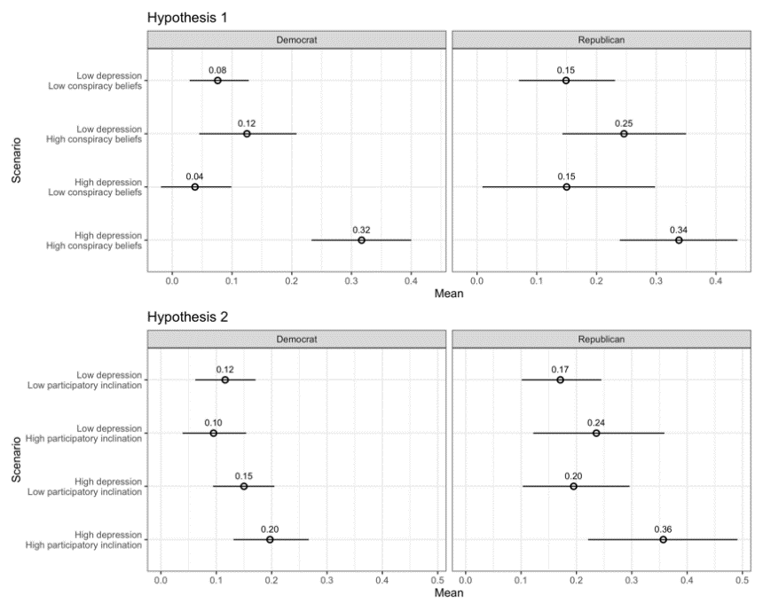

Figure A.5 Split Sample Replication for Partisans on Support for Capitol Riots – Test of Hypothesis 3
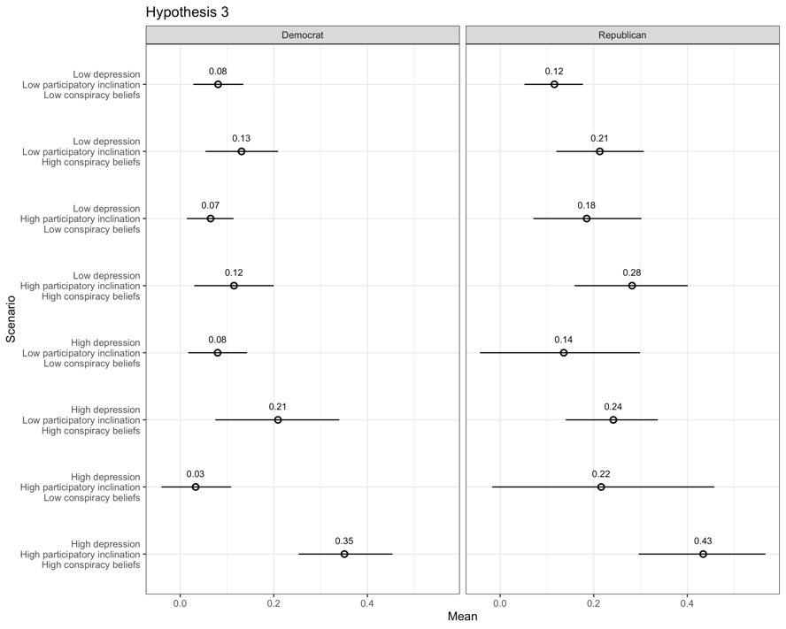
Figure A.6. Split Sample Replication for Partisans on Hypothetical Election Violence (January) – Test of Hypotheses 1 and 2
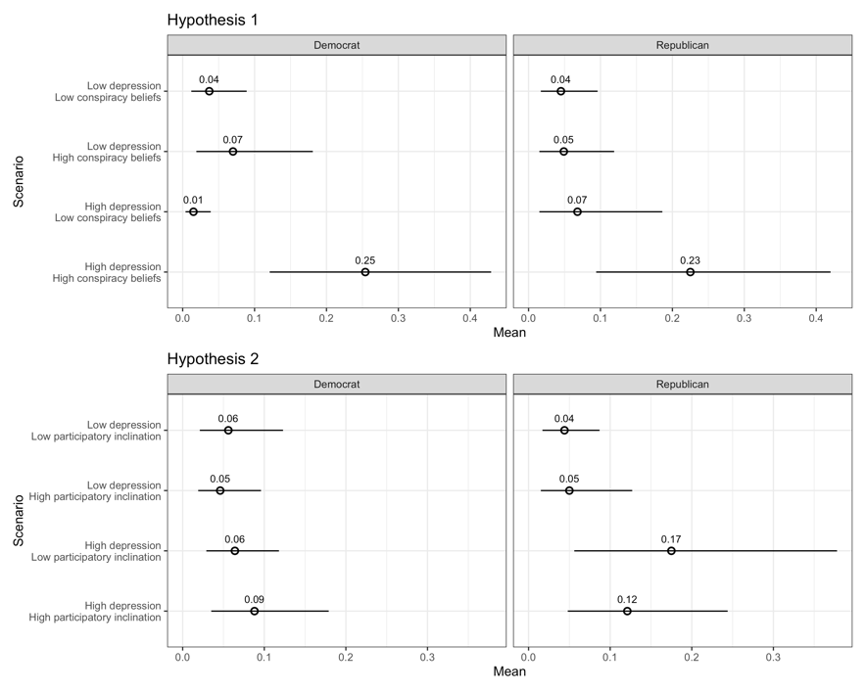
Figure A.7. Split Sample Replication for Partisans on Hypothetical Election Violence (January) – Test of Hypothesis 3
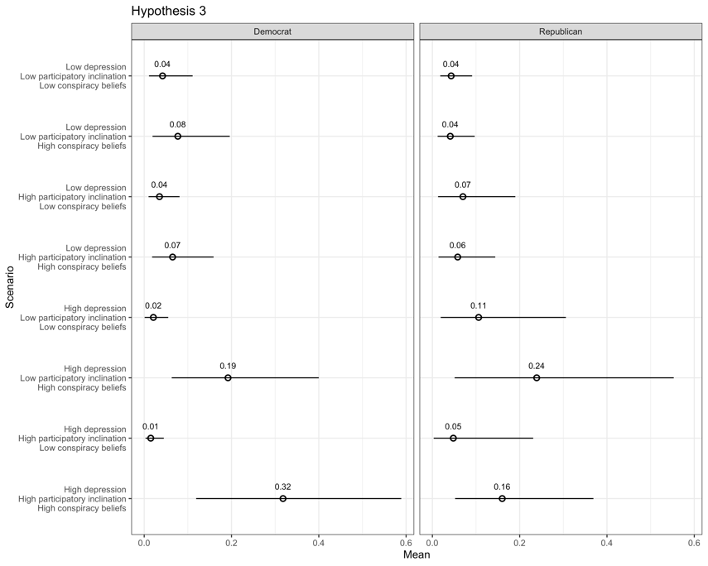

Figure A.8. Split Sample Replication by Trump Support for Support for Capitol Riots – Test of Hypotheses 1 and 2
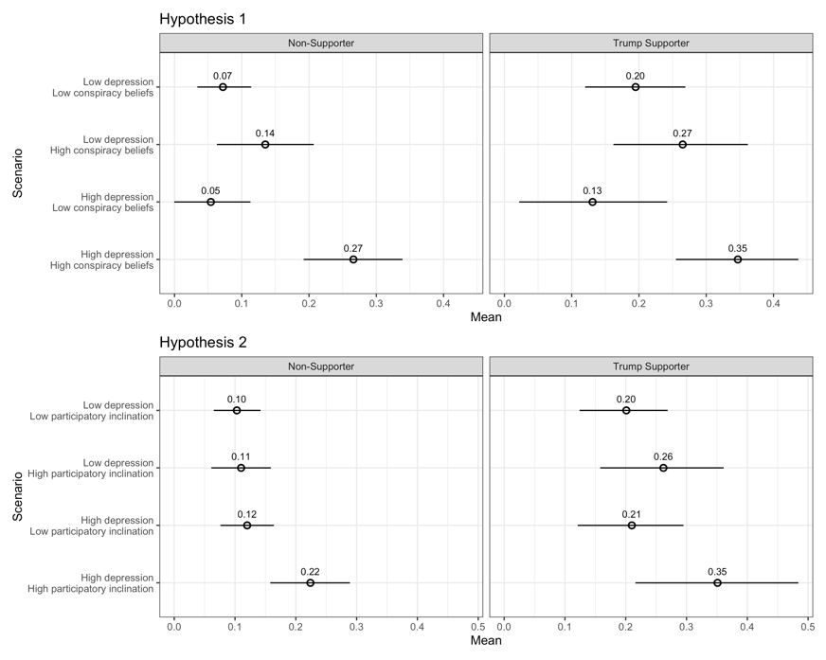
Figure A.9. Split Sample Replication by Trump Support for Support for Capitol Riots – Test of Hypothesis 3
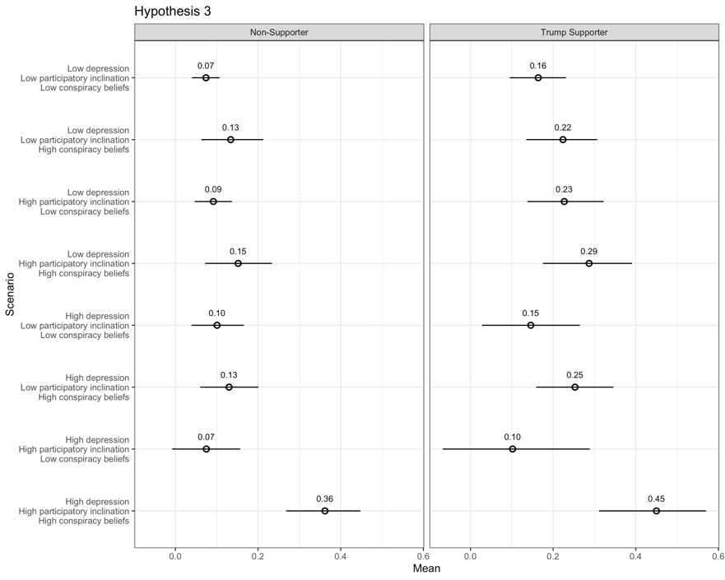

Figure A.10. Split Sample Replication by Trump Support for Hypothetical Election Violence (January) – Test of Hypotheses 1 and 2
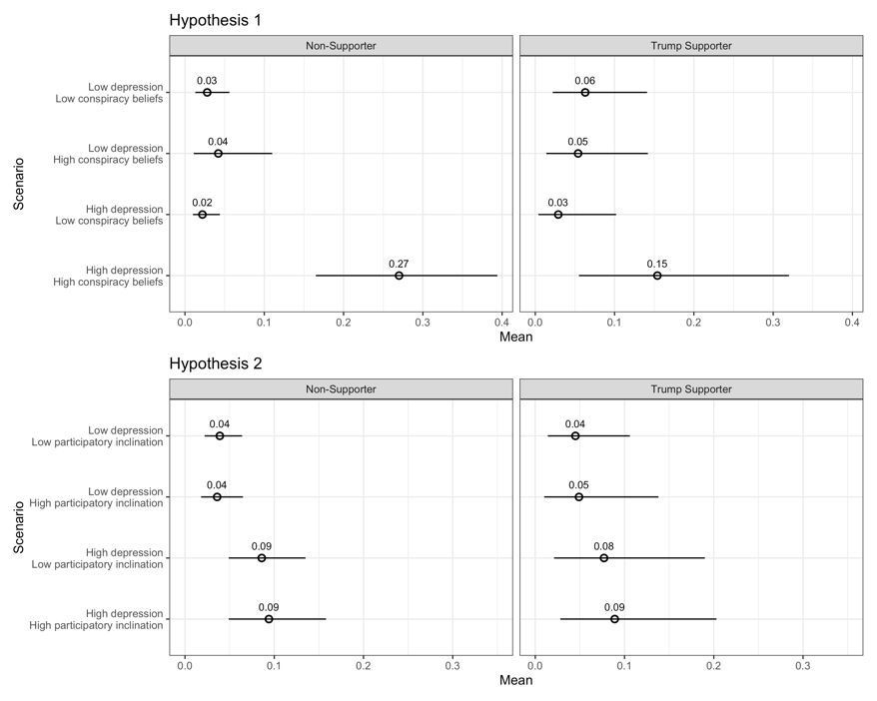
Figure A.11. Split Sample Replication by Trump Support for Hypothetical Election Violence (January) – Test of Hypothesis 3
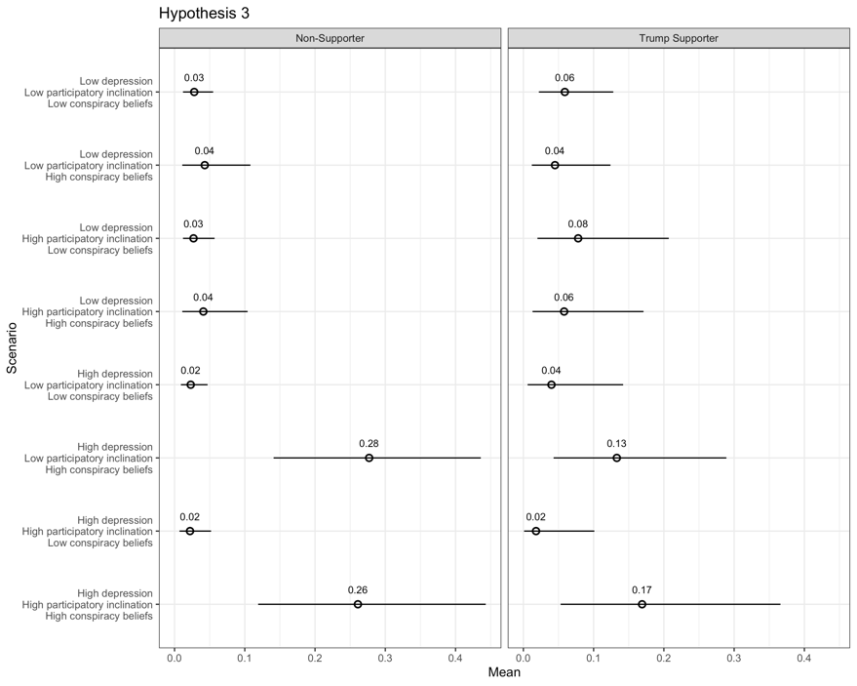
Table A.11: Split Sample Replication for Democrats Only (January Data)
 |  | Support Capital Riot |  |  | Hypothetical Election Violence (January)
 |  | (1) | (2) | (3) | (4) | (5) | (6)
Depression |  | 0.00218 | -0.00239 | -3.52e-05 | -0.0584 | 0.0113 | -0.0457
 |  | (0.00164) | (0.00187) | (0.00255) | (0.0402) | (0.0312) | (0.0462)
Conspiracy Beliefs |  | 0.373*** | 0.115 | 0.120 | 1.507 | 4.334*** | 1.439
 |  | (0.102) | (0.109) | (0.113) | (1.935) | (1.005) | (1.929)
Participatory |  | -0.0204 | -0.00199 | -0.0161 | -0.0562 | -0.174 | -0.188
Inclination |  | (0.0236) | (0.0184) | (0.0232) | (0.299) | (0.435) | (0.422)
Ideology |  | 0.00266 | 0.00231 | 0.00328 | 0.104 | 0.0868 | 0.112
 |  | (0.00808) | (0.00778) | (0.00786) | (0.115) | (0.113) | (0.117)
Political Interest |  | 0.00144 | 0.00409 | 0.00326 | -0.000655 | -0.0403 | -0.00285
 |  | (0.0110) | (0.00954) | (0.00984) | (0.136) | (0.132) | (0.136)
Black |  | -0.0928 | -0.0900 | -0.0984 | -0.880 | -0.928 | -0.934
 |  | (0.101) | (0.105) | (0.105) | (0.590) | (0.626) | (0.580)
White |  | -0.133 | -0.125 | -0.130 | -1.017 | -1.188^ | -1.045^
 |  | (0.101) | (0.105) | (0.106) | (0.637) | (0.663) | (0.621)
Asian |  | -0.137 | -0.139 | -0.142 | -0.896 | -0.915 | -0.919
 |  | (0.105) | (0.109) | (0.111) | (0.644) | (0.689) | (0.642)
Hispanic |  | -0.113 | -0.106 | -0.110 | -1.031 | -1.120^ | -1.051^
 |  | (0.105) | (0.109) | (0.110) | (0.638) | (0.669) | (0.630)
Income |  | 0.00355 | 0.00321 | 0.00301 | 0.0366 | 0.0336 | 0.0364
 |  | (0.00470) | (0.00458) | (0.00449) | (0.0603) | (0.0612) | (0.0608)
Education |  | 0.00531 | 0.00388 | 0.00128 | -0.0271 | 0.0164 | -0.0527
 |  | (0.00925) | (0.00891) | (0.00865) | (0.135) | (0.134) | (0.145)
Age |  | -0.00106* | -0.00126** | -0.00115** | -0.0451*** | -0.0414*** | -0.0443***
 |  | (0.000465) | (0.000443) | (0.000427) | (0.0112) | (0.0114) | (0.0111)
Facebook Election News |  | 0.0588*** | 0.0597*** | 0.0579*** | 0.577* | 0.559* | 0.570*
 |  | (0.0158) | (0.0156) | (0.0157) | (0.281) | (0.281) | (0.283)
Election Confidence |  | 0.0108 | 0.00536 | 0.00323 | -0.319 | -0.250 | -0.338
 |  | (0.0133) | (0.0101) | (0.0105) | (0.225) | (0.217) | (0.226)
Trump Supporter |  | 0.131** | 0.117** | 0.126** | -0.863 | -0.578 | -0.800
 |  | (0.0448) | (0.0423) | (0.0430) | (0.815) | (0.764) | (0.797)
Male |  | 0.0328^ | 0.0196 | 0.0193 | 0.401 | 0.571^ | 0.387
 |  | (0.0175) | (0.0167) | (0.0163) | (0.298) | (0.301) | (0.300)
Depression X |  | 0.00412 |  | -0.00205 |  | 0.0310 | -0.0116
Participatory Inclination |  | (0.00273) |  | (0.00342) |  | (0.0411) | (0.0542)
Depression X |  |  | 0.0343** | 0.0121 | 0.385* |  | 0.274
Conspiracy Beliefs |  |  | (0.0110) | (0.0158) | (0.164) |  | (0.186)
Depression X |  |  |  | 0.0277 |  |  | 0.161
Conspiracy Beliefs X Participatory Inclination |  |  |  | (0.0169) |  |  | (0.190)
Constant 1 |  | 0.0461 | 0.107 | 0.127 | -1.527 | -0.718 | -1.708
 |  | (0.0996) | (0.0974) | (0.0984) | (1.071) | (1.101) | (1.144)
Constant 2 |  |  |  |  | -0.0485 | 0.704 | -0.220
 |  |  |  |  | (1.119) | (1.158) | (1.202)
Observations |  | 698 | 698 | 698 | 698 | 698 | 698
R-squared |  | 0.245 | 0.277 | 0.288
Robust standard errors in parentheses
*** p<0.001, ** p<0.01, * p<0.05, ^ p<0.10 for two-tailed tests

Table A.12: Split Sample Replication for Republicans Only (January Data)
 |  | Support Capital Riot |  |  | Hypothetical Election Violence (January)
 |  | (1) | (2) | (3) | (4) | (5) | (6)
Depression |  | 0.00148 | 0.000282 | 0.00117 | 0.0200 | 0.0915* | 0.0509
 |  | (0.00336) | (0.00523) | (0.00636) | (0.0501) | (0.0397) | (0.0593)
Conspiracy |  | 0.327** | 0.226^ | 0.233^ | 0.171 | 2.215* | -0.294
Beliefs |  | (0.108) | (0.120) | (0.119) | (1.388) | (0.965) | (1.479)
Participatory |  | 0.0618 | 0.101** | 0.0672 | -0.0952 | 0.0584 | 0.371
Inclination |  | (0.0483) | (0.0356) | (0.0481) | (0.445) | (0.577) | (0.646)
Ideology |  | 0.00150 | 0.00128 | 0.00180 | -0.0327 | -0.0281 | -0.0265
 |  | (0.0128) | (0.0126) | (0.0127) | (0.113) | (0.108) | (0.117)
Political Interest |  | 0.0111 | 0.0109 | 0.0118 | -0.386* | -0.426** | -0.386*
 |  | (0.0129) | (0.0128) | (0.0128) | (0.162) | (0.163) | (0.165)
Black |  | -0.0624 | -0.0536 | -0.0508 | -0.287 | -0.445 | -0.345
 |  | (0.122) | (0.120) | (0.119) | (1.346) | (1.290) | (1.330)
White |  | -0.0901 | -0.0855 | -0.0876 | -0.459 | -0.588 | -0.437
 |  | (0.0933) | (0.0914) | (0.0897) | (1.255) | (1.219) | (1.247)
Asian |  | -0.0176 | -0.0131 | -0.0143 | 0.172 | 0.00990 | 0.191
 |  | (0.105) | (0.104) | (0.102) | (1.339) | (1.315) | (1.338)
Hispanic |  | -0.0868 | -0.0798 | -0.0833 | -0.844 | -0.967 | -0.791
 |  | (0.105) | (0.104) | (0.102) | (1.453) | (1.404) | (1.444)
Income |  | -0.00343 | -0.00184 | -0.00296 | -0.145^ | -0.138^ | -0.139
 |  | (0.00615) | (0.00642) | (0.00607) | (0.0845) | (0.0813) | (0.0863)
Education |  | 0.00737 | 0.00762 | 0.00548 | 0.0365 | 0.0581 | 0.0655
 |  | (0.0153) | (0.0150) | (0.0150) | (0.157) | (0.160) | (0.170)
Age |  | -0.00556*** | -0.00564*** | -0.00556*** | -0.0540*** | -0.0536*** | -0.0529***
 |  | (0.00109) | (0.00108) | (0.00109) | (0.0107) | (0.0107) | (0.0105)
Facebook Election News |  | 0.0187 | 0.0146 | 0.0172 | 1.102** | 1.104** | 1.066**
 |  | (0.0291) | (0.0289) | (0.0289) | (0.388) | (0.383) | (0.388)
Election Confidence |  | 0.0163 | 0.0153 | 0.0113 | 0.582*** | 0.657*** | 0.581***
 |  | (0.0156) | (0.0145) | (0.0154) | (0.175) | (0.170) | (0.173)
Trump Supporter |  | 0.0610 | 0.0648^ | 0.0656^ | 0.284 | 0.197 | 0.280
 |  | (0.0393) | (0.0380) | (0.0383) | (0.464) | (0.490) | (0.470)
Male |  | 0.0401 | 0.0434 | 0.0402 | 0.988** | 1.013** | 0.963**
 |  | (0.0271) | (0.0268) | (0.0269) | (0.335) | (0.330) | (0.331)
Depression X |  | 0.00636 |  | 0.00122 |  | -0.0274 | -0.101
Participatory Inclination |  | (0.00672) |  | (0.0108) |  | (0.0558) | (0.101)
Depression X |  |  | 0.0132 | 0.00178 | 0.215 |  | 0.170
Conspiracy Beliefs |  |  | (0.0128) | (0.0157) | (0.143) |  | (0.199)
Depression X |  |  |  | 0.0154 |  |  | 0.147
Conspiracy Beliefs X Participatory Inclination |  |  |  | (0.0216) |  |  | (0.213)
Constant 1 |  | 0.298* | 0.305* | 0.323* | 0.00719 | 0.558 | 0.201
 |  | (0.135) | (0.128) | (0.128) | (1.599) | (1.552) | (1.589)
Constant 2 |  |  |  |  | 1.016 | 1.554 | 1.214
 |  |  |  |  | (1.607) | (1.565) | (1.599)
Observations |  | 527 | 527 | 527 | 530 | 530 | 530
R-squared |  | 0.337 | 0.336 | 0.340
Robust standard errors in parentheses
*** p<0.001, ** p<0.01, * p<0.05, ^ p<0.10 for two-tailed tests

Table A.13: Split Sample Replication for Trump Supporters Only (January Data)
 |  | Support Capitol Riot |  |  | Hypothetical Election Violence (January)
 |  | (1) | (2) | (3) | (4) | (5) | (6)
Depression |  | 0.000582 | -0.00390 | -0.00119 | -0.0599 | 0.0341 | -0.0374
 |  | (0.00287) | (0.00437) | (0.00469) | (0.0551) | (0.0285) | (0.0571)
Conspiracy Beliefs |  | 0.308** | 0.159 | 0.140 | -0.532 | 1.926^ | -0.861
 |  | (0.100) | (0.109) | (0.109) | (1.353) | (1.005) | (1.381)
Participatory |  | 0.0591 | 0.0889** | 0.0648 | 0.103 | 0.0133 | 0.241
Inclination |  | (0.0421) | (0.0331) | (0.0400) | (0.360) | (0.503) | (0.544)
Democrat |  | 0.0615 | 0.0843 | 0.0737 | 0.345 | 0.112 | 0.436
 |  | (0.195) | (0.203) | (0.189) | (0.993) | (1.076) | (1.003)
Republican |  | 0.0807 | 0.103 | 0.0962 | 0.769 | 0.730 | 0.852
 |  | (0.191) | (0.200) | (0.184) | (0.824) | (0.816) | (0.807)
Independent |  | 0.115 | 0.132 | 0.128 | 1.154 | 1.167 | 1.280
 |  | (0.191) | (0.199) | (0.184) | (0.896) | (0.959) | (0.884)
Ideology |  | -0.00342 | -0.00368 | -0.00561 | 0.0107 | 0.0183 | 0.00572
 |  | (0.0125) | (0.0119) | (0.0112) | (0.128) | (0.135) | (0.126)
Political Interest |  | 0.00728 | 0.00672 | 0.00812 | -0.445** | -0.457** | -0.444**
 |  | (0.0118) | (0.0115) | (0.0114) | (0.146) | (0.147) | (0.147)
Black |  | -0.0485 | -0.0375 | -0.0396 | -1.915 | -2.143^ | -1.809
 |  | (0.104) | (0.103) | (0.101) | (1.221) | (1.192) | (1.270)
White |  | 0.00111 | 0.00193 | -0.00567 | -0.799 | -0.804 | -0.782
 |  | (0.0845) | (0.0834) | (0.0822) | (0.887) | (0.849) | (0.901)
Asian |  | -0.0265 | -0.0271 | -0.0336 | -0.511 | -0.522 | -0.496
 |  | (0.0961) | (0.0951) | (0.0944) | (0.989) | (0.937) | (1.005)
Hispanic |  | -0.0256 | -0.0185 | -0.0270 | -1.034 | -1.120 | -1.051
 |  | (0.0929) | (0.0919) | (0.0909) | (1.115) | (1.064) | (1.137)
Income |  | -0.00324 | -0.00330 | -0.00246 | -0.0928 | -0.0582 | -0.0863
 |  | (0.00647) | (0.00652) | (0.00616) | (0.0734) | (0.0810) | (0.0726)
Education |  | 0.0133 | 0.0130 | 0.00968 | 0.0227 | 0.00389 | 0.0290
 |  | (0.0136) | (0.0131) | (0.0130) | (0.161) | (0.187) | (0.162)
Age |  | -0.00461*** | -0.00464*** | -0.00459*** | -0.0472*** | -0.0486*** | -0.0470***
 |  | (0.00108) | (0.00107) | (0.00107) | (0.00932) | (0.00935) | (0.00925)
Facebook Election News |  | 0.0308 | 0.0334 | 0.0282 | 1.027** | 0.946** | 1.020**
 |  | (0.0280) | (0.0276) | (0.0273) | (0.336) | (0.325) | (0.338)
Election Confidence |  | -0.00212 | -0.00476 | -0.0110 | 0.468** | 0.494** | 0.435**
 |  | (0.0155) | (0.0147) | (0.0150) | (0.160) | (0.162) | (0.167)
Male |  | 0.0530* | 0.0549* | 0.0594* | 0.968*** | 0.987*** | 0.994***
 |  | (0.0255) | (0.0251) | (0.0249) | (0.289) | (0.287) | (0.295)
Depression X |  | 0.00508 |  | -0.00677 |  | 0.0102 | -0.102
Participatory Inclination |  | (0.00605) |  | (0.00777) |  | (0.0510) | (0.0990)
Depression X |  |  | 0.0220^ | 0.00708 | 0.332* |  | 0.273^
Conspiracy Beliefs |  |  | (0.0115) | (0.0123) | (0.146) |  | (0.151)
Depression X |  |  |  | 0.0367^ |  |  | 0.249
Conspiracy Beliefs X Participatory Inclination |  |  |  | (0.0199) |  |  | (0.203)
Constant 1 |  | 0.205 | 0.222 | 0.268 | -0.164 | 0.439 | -0.115
 |  | (0.216) | (0.220) | (0.205) | (1.355) | (1.262) | (1.341)
Constant 2 |  |  |  |  | 0.928 | 1.491 | 0.982
 |  |  |  |  | (1.325) | (1.237) | (1.311)
Observations |  | 614 | 614 | 614 | 614 | 614 | 614
R-squared |  | 0.213 | 0.218 | 0.229
Robust standard errors in parentheses
*** p<0.001, ** p<0.01, * p<0.05, ^ p<0.10 for two-tailed tests

Table A.14: Split Sample Replication for Trump Non-Supporters Only (January Data)
 |  | Support Capitol Riot |  |  | Hypothetical Election Violence (January)
 |  | (1) | (2) | (3) | (4) | (5) | (6)
Depression |  | 0.00106 | -0.00111 | 0.00112 | -0.0158 | 0.0534** | -0.0147
 |  | (0.00141) | (0.00187) | (0.00225) | (0.0299) | (0.0195) | (0.0323)
Conspiracy Beliefs |  | 0.321*** | 0.151 | 0.145 | 0.797 | 3.902*** | 0.797
 |  | (0.0843) | (0.109) | (0.114) | (1.871) | (0.712) | (1.876)
Participatory |  | 0.00728 | 0.0451* | 0.0133 | -0.0813 | -0.0769 | -0.0540
Inclination |  | (0.0228) | (0.0191) | (0.0223) | (0.247) | (0.333) | (0.331)
Ideology |  | 0.00945 | 0.00949 | 0.0148* | -0.0359 | -0.0477 | -0.0361
 |  | (0.00728) | (0.00723) | (0.00676) | (0.0866) | (0.0849) | (0.0874)
Political Interest |  | -0.00494 | -0.00399 | -0.00503 | -0.0970 | -0.103 | -0.0965
 |  | (0.00764) | (0.00709) | (0.00699) | (0.107) | (0.0963) | (0.108)
Black |  | 0.0453 | 0.0495 | 0.0379 | -0.770^ | -0.742 | -0.766^
 |  | (0.0688) | (0.0696) | (0.0712) | (0.434) | (0.456) | (0.438)
White |  | -0.00993 | -0.00529 | -0.00630 | -1.147** | -1.207** | -1.144*
 |  | (0.0665) | (0.0672) | (0.0698) | (0.444) | (0.462) | (0.445)
Asian |  | 0.0360 | 0.0427 | 0.0384 | -0.976^ | -1.038^ | -0.974^
 |  | (0.0747) | (0.0756) | (0.0788) | (0.530) | (0.557) | (0.532)
Hispanic |  | 0.0525 | 0.0592 | 0.0601 | -1.198* | -1.188* | -1.193*
 |  | (0.0722) | (0.0731) | (0.0755) | (0.485) | (0.504) | (0.490)
Income |  | 0.00196 | 0.00153 | 0.00186 | 0.0455 | 0.0458 | 0.0454
 |  | (0.00365) | (0.00363) | (0.00364) | (0.0487) | (0.0490) | (0.0486)
Education |  | -0.00730 | -0.00780 | -0.0101 | 0.00655 | 0.0326 | 0.00705
 |  | (0.00770) | (0.00766) | (0.00754) | (0.102) | (0.104) | (0.104)
Age |  | -0.00156*** | -0.00164*** | -0.00151*** | -0.0337*** | -0.0323*** | -0.0337***
 |  | (0.000457) | (0.000462) | (0.000444) | (0.00729) | (0.00743) | (0.00727)
Facebook Election News |  | 0.0253 | 0.0260^ | 0.0179 | 0.801*** | 0.792*** | 0.801***
 |  | (0.0155) | (0.0155) | (0.0166) | (0.218) | (0.222) | (0.220)
Election Confidence |  | -0.0157 | -0.0173^ | -0.0248** | -0.383** | -0.361** | -0.383**
 |  | (0.0101) | (0.00918) | (0.00934) | (0.132) | (0.126) | (0.133)
Democrat |  | -0.0328 | -0.0378 |  | 0.706 | 0.697 | 0.703
 |  | (0.0515) | (0.0526) |  | (0.505) | (0.517) | (0.511)
Republican |  | 0.0621 | 0.0515 |  | 0.385 | 0.644 | 0.385
 |  | (0.0601) | (0.0616) |  | (0.610) | (0.620) | (0.608)
Independent |  | -0.00419 | -0.0103 |  | 0.606 | 0.612 | 0.604
 |  | (0.0498) | (0.0508) |  | (0.467) | (0.480) | (0.471)
Male |  | 0.0246 | 0.0187 | 0.0160 | 0.511* | 0.581** | 0.509*
 |  | (0.0152) | (0.0148) | (0.0146) | (0.218) | (0.217) | (0.221)
Depression X |  | 0.00601* |  | -0.00217 |  | 0.00913 | -0.00407
Participatory Inclination |  | (0.00274) |  | (0.00361) |  | (0.0312) | (0.0401)
Depression X |  |  | 0.0223* | -0.00272 | 0.375* |  | 0.373*
Conspiracy Beliefs |  |  | (0.00898) | (0.0116) | (0.159) |  | (0.166)
Depression X |  |  |  | 0.0388** |  |  | 0.00354
Conspiracy Beliefs X Participatory Inclination |  |  |  | (0.0123) |  |  | (0.134)
Constant 1 |  | 0.127 | 0.156^ | 0.161* | -0.947 | -0.222 | -0.940
 |  | (0.0837) | (0.0828) | (0.0708) | (0.822) | (0.840) | (0.832)
Constant 2 |  |  |  |  | 0.739 | 1.391 | 0.747
 |  |  |  |  | (0.847) | (0.871) | (0.860)
Observations |  | 1,151 | 1,151 | 1,152 | 1,155 | 1,155 | 1,155
R-squared |  | 0.240 | 0.246 | 0.261
Robust standard errors in parentheses
*** p<0.001, ** p<0.01, * p<0.05, ^ p<0.10 for two-tailed tests

- Additional Gender Analyses
In the paper, we presented gender results for the January Hypothetical Election Violence outcome. Here, we present the results with the other two outcomes and discuss the results overall. Note that, as with the partisanship and Trump supporter subgroup analyses, we lose substantial statistical power when we divide the sample by gender (in essence pursuing a 4-way interaction). This is particularly the case with our January data where our sample size is substantially smaller. The figures for each group for each outcome appear below (as do the tables). In the November data, we find that the predicted associations for all hypotheses hold for both men and women. When we turn to the smaller data sets, we find that for men, all results hold in the January data at the .10 significance level or better (using two-tailed tests). Specifically, in two of the tests – the conspiracy interaction for the Support Capitol Riot outcome and the three-way interaction for the January Hypothetical Election outcome – the significance level is at the .10 level (likely reflecting the smaller samples as the standard errors grow substantially). In the all the other tests (i.e., 7 of the 9 if we include those reported in the paper), it is significant at the .05 level. For women, as mentioned in the paper, we find no significance in two cases with the January Hypothetical Election outcome (i.e., the interaction with a participatory inclination and the three-way interaction). Otherwise, we find significance at the .05 level in 5 of 9 cases (i.e., when we also account for the results presented in the paper); in the other two, it falls short of any conventional levels (p < .15 for the Support Capitol Riot interaction with participation and p < .18 for the Support Capitol Riot three-way interaction). In sum, we find consistent support for men, as expected, in 7 of 9 cases with the other 2 being at the .10 level (stemming surely from the reduced sample size). We find mixed support for women with clear significance 5 out of 9 times. This all coheres with the anticipated gender heterogeneity.

Figure A.12. Split Sample Replication by gender for Support of Capitol Riots – Test of Hypotheses 1 and 2
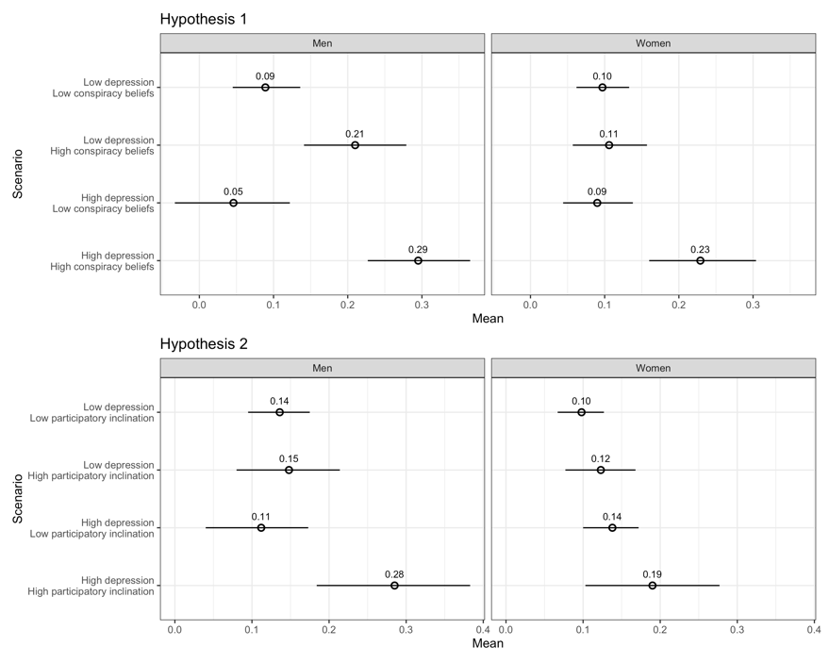

Figure A.13. Split Sample Replication by gender for Support of Capitol Riots – Test of Hypothesis 3
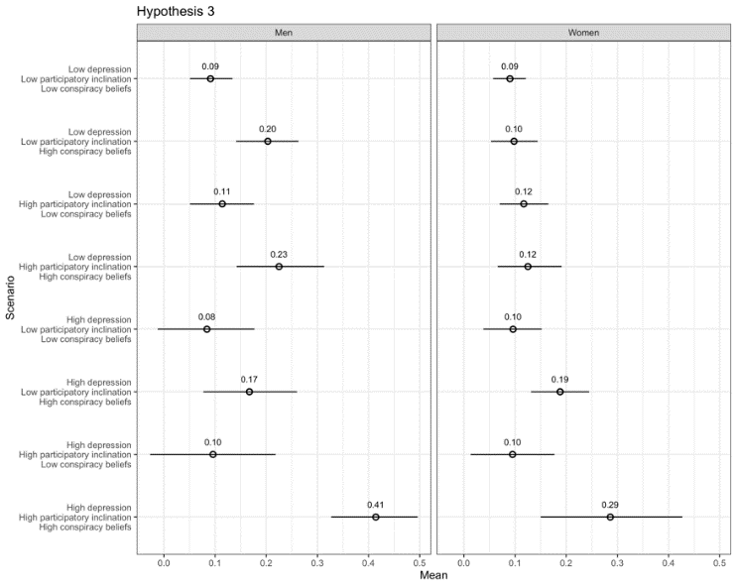
Figure A.14. Split Sample Replication by gender for Hypothetical Election Violence (November) – Test of Hypotheses 1 and 2
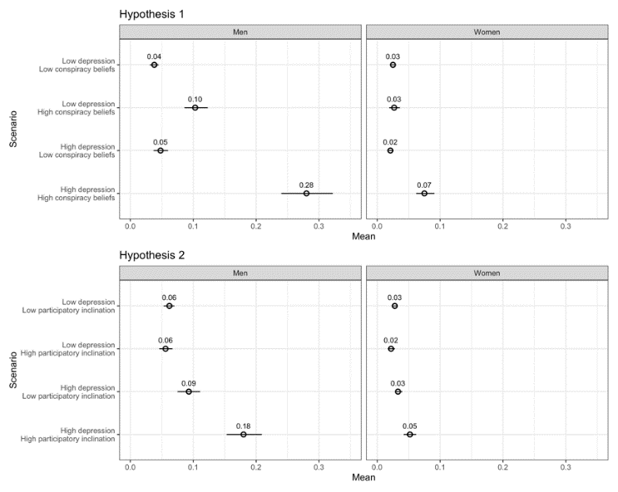
Figure A.15. Split Sample Replication by gender for Hypothetical Election Violence (November) – Test of Hypothesis 3
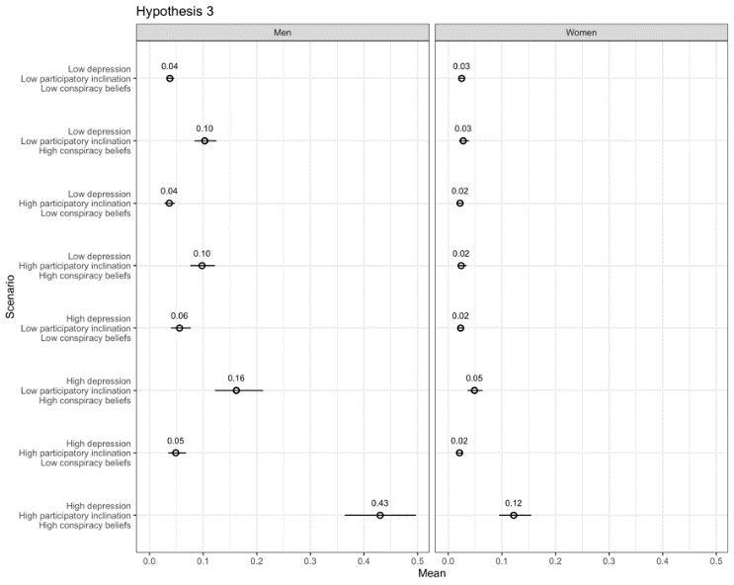

Table A.15: Split Sample Replication for Females Only
 | Support Capitol Riot |  |  | Hypothetical Election Violence (November)
 | (1) | (2) | (3) |  | (4) | (5) | (6)
Depression | 0.00250^ | -0.000450 | 0.000317 |  | -0.00945 | 0.00995 | -0.00529
 | (0.00139) | (0.00201) | (0.00237) |  | (0.00853) | (0.00663) | (0.0100)
Conspiracy Beliefs | 0.147* | 0.0203 | 0.0203 |  | 0.176 | 1.710*** | 0.305
 | (0.0700) | (0.0784) | (0.0785) |  | (0.502) | (0.266) | (0.497)
Participatory | 0.0249 | 0.0355^ | 0.0266 |  | 0.152* | -0.226^ | -0.156
Inclination | (0.0248) | (0.0210) | (0.0239) |  | (0.0771) | (0.130) | (0.132)
Democrat | -0.102 | -0.106 | -0.103 |  | -0.357** | -0.334* | -0.347*
 | (0.0651) | (0.0664) | (0.0666) |  | (0.137) | (0.138) | (0.136)
Republican | -0.0710 | -0.0803 | -0.0752 |  | -0.247 | -0.226 | -0.255
 | (0.0728) | (0.0741) | (0.0742) |  | (0.161) | (0.162) | (0.160)
Independent | -0.0615 | -0.0686 | -0.0667 |  | -0.388** | -0.352** | -0.387**
 | (0.0643) | (0.0658) | (0.0660) |  | (0.132) | (0.133) | (0.131)
Ideology | 0.0215** | 0.0211** | 0.0204** |  | -0.0718* | -0.0712* | -0.0775**
 | (0.00665) | (0.00678) | (0.00654) |  | (0.0287) | (0.0287) | (0.0288)
Political Interest | 0.00435 | 0.00428 | 0.00401 |  | -0.0813* | -0.0875** | -0.0827*
 | (0.00698) | (0.00667) | (0.00673) |  | (0.0337) | (0.0332) | (0.0338)
Black | -0.00516 | -0.00259 | -0.00447 |  | 0.398* | 0.384* | 0.365*
 | (0.0480) | (0.0479) | (0.0475) |  | (0.181) | (0.178) | (0.177)
White | -0.0444 | -0.0413 | -0.0429 |  | -0.355* | -0.362* | -0.364*
 | (0.0449) | (0.0447) | (0.0445) |  | (0.168) | (0.165) | (0.164)
Asian | -0.0187 | -0.0202 | -0.0236 |  | 0.370^ | 0.358 | 0.354
 | (0.0514) | (0.0514) | (0.0512) |  | (0.218) | (0.219) | (0.216)
Hispanic | 0.0145 | 0.0187 | 0.0169 |  | 0.289 | 0.275 | 0.266
 | (0.0532) | (0.0534) | (0.0526) |  | (0.182) | (0.179) | (0.178)
Income | -0.00800* | -0.00788* | -0.00779* |  | -0.0482* | -0.0487* | -0.0494*
 | (0.00361) | (0.00354) | (0.00358) |  | (0.0193) | (0.0193) | (0.0192)
Education | 0.00159 | 0.00109 | 0.000880 |  | -0.182*** | -0.178*** | -0.185***
 | (0.00775) | (0.00762) | (0.00764) |  | (0.0430) | (0.0435) | (0.0431)
Age | -0.00172*** | -0.00179*** | -0.00177*** |  | -0.0235*** | -0.0234*** | -0.0231***
 | (0.000517) | (0.000530) | (0.000514) |  | (0.00249) | (0.00250) | (0.00250)
Facebook Election News | 0.0209 | 0.0209 | 0.0216
 | (0.0151) | (0.0149) | (0.0149)
Election Confidence | -0.0192* | -0.0207* | -0.0215* |  | -0.0257 | -0.0162 | -0.0387
 | (0.00886) | (0.00833) | (0.00849) |  | (0.0460) | (0.0459) | (0.0459)
Trump Supporter | 0.0294 | 0.0334 | 0.0315 |  | -0.270* | -0.294* | -0.282*
 | (0.0346) | (0.0338) | (0.0340) |  | (0.132) | (0.132) | (0.131)
Depression X | 0.00168 |  | -0.00148 |  |  | 0.0383*** | 0.00354
Participatory Inclination | (0.00349) |  | (0.00370) |  |  | (0.0104) | (0.0130)
Depression X |  | 0.0190* | 0.0124 |  | 0.155*** |  | 0.0811*
Conspiracy Beliefs |  | (0.00876) | (0.00954) |  | (0.0339) |  | (0.0393)
Depression X |  |  | 0.0145 |  |  |  | 0.135***
Conspiracy Beliefs X Participatory Inclination |  |  | (0.0140) |  |  |  | (0.0346)
Constant 1 | 0.215** | 0.248** | 0.254** |  | -0.772** | -0.541^ | -0.906**
 | (0.0822) | (0.0834) | (0.0830) |  | (0.296) | (0.291) | (0.295)
Constant 2 |  |  |  |  | 0.727* | 0.949*** | 0.607*
 |  |  |  |  | (0.290) | (0.287) | (0.289)
Observations | 1,063 | 1,063 | 1,063 |  | 12,895 | 12,895 | 12,895
R-squared | 0.184 | 0.193 | 0.196
Robust standard errors in parentheses
*** p<0.001, ** p<0.01, * p<0.05, ^ p<0.10 for two-tailed tests

Table A.16: Split Sample Replication for Males Only
 |  | Support Capitol Riot |  |  | Hypothetical Election Violence (November)
 | (1) |  | (2) | (3) | (4) | (5) | (6)
Depression | -0.00153 |  | -0.00266 | -0.000441 | 0.0138 | 0.0249** | 0.0218^
 | (0.00211) |  | (0.00264) | (0.00316) | (0.00894) | (0.00779) | (0.0112)
Conspiracy | 0.418*** |  | 0.289** | 0.262* | 2.391*** | 3.478*** | 2.338***
Beliefs | (0.0914) |  | (0.110) | (0.110) | (0.333) | (0.209) | (0.344)
Participatory | 0.0118 |  | 0.0703* | 0.0234 | 0.301*** | -0.104 | -0.0441
Inclination | (0.0349) |  | (0.0282) | (0.0342) | (0.0853) | (0.122) | (0.124)
Democrat | 0.0278 |  | 0.0277 | 0.0345 | -0.119 | -0.171 | -0.148
 | (0.0716) |  | (0.0748) | (0.0690) | (0.194) | (0.193) | (0.189)
Republican | 0.0927 |  | 0.104 | 0.0892 | -0.0806 | -0.130 | -0.131
 | (0.0791) |  | (0.0838) | (0.0752) | (0.213) | (0.211) | (0.208)
Independent | 0.0790 |  | 0.0786 | 0.0833 | -0.193 | -0.237 | -0.230
 | (0.0709) |  | (0.0745) | (0.0675) | (0.191) | (0.190) | (0.185)
Ideology | -0.00701 |  | -0.00648 | -0.00642 | -0.120*** | -0.120*** | -0.127***
 | (0.0102) |  | (0.0101) | (0.0100) | (0.0293) | (0.0294) | (0.0302)
Political Interest | -0.00692 |  | -0.00781 | -0.00443 | -0.126** | -0.130** | -0.123**
 | (0.0117) |  | (0.0117) | (0.0115) | (0.0415) | (0.0413) | (0.0415)
Black | 0.0692 |  | 0.0722 | 0.0593 | 1.020*** | 1.067*** | 1.015***
 | (0.103) |  | (0.102) | (0.103) | (0.245) | (0.243) | (0.240)
White | 0.0297 |  | 0.0288 | 0.0243 | 0.496* | 0.527* | 0.485*
 | (0.0988) |  | (0.0970) | (0.0987) | (0.228) | (0.225) | (0.223)
Asian | 0.0575 |  | 0.0601 | 0.0539 | 0.579* | 0.602* | 0.576*
 | (0.106) |  | (0.104) | (0.106) | (0.278) | (0.278) | (0.276)
Hispanic | 0.0510 |  | 0.0550 | 0.0519 | 0.697** | 0.713** | 0.696**
 | (0.104) |  | (0.102) | (0.104) | (0.253) | (0.251) | (0.248)
Income | 0.00521 |  | 0.00588 | 0.00545 | 0.0374* | 0.0411* | 0.0358^
 | (0.00527) |  | (0.00540) | (0.00518) | (0.0186) | (0.0186) | (0.0186)
Education | -0.00860 |  | -0.00696 | -0.0108 | 0.0801* | 0.0788* | 0.0636
 | (0.0102) |  | (0.0103) | (0.0101) | (0.0389) | (0.0392) | (0.0395)
Age | -0.00364*** |  | -0.00353*** | -0.00347*** | -0.0167*** | -0.0161*** | -0.0162***
 | (0.000766) |  | (0.000786) | (0.000754) | (0.00278) | (0.00279) | (0.00279)
Facebook Election | 0.0362 |  | 0.0389^ | 0.0312
News | (0.0221) |  | (0.0224) | (0.0222)
Election | -0.00614 |  | -0.00578 | -0.0122 | 0.119* | 0.127** | 0.0871^
Confidence | (0.0139) |  | (0.0134) | (0.0134) | (0.0462) | (0.0458) | (0.0468)
Trump Supporter | 0.113*** |  | 0.109** | 0.129*** | -0.182 | -0.196 | -0.165
 | (0.0335) |  | (0.0332) | (0.0313) | (0.133) | (0.131) | (0.132)
Depression X | 0.00998* |  |  | -0.000623 |  | 0.0482*** | -0.00476
Participatory Inclination | (0.00442) |  |  | (0.00588) |  | (0.0110) | (0.0143)
Depression X |  |  | 0.0191* | -0.00435 | 0.121*** |  | 0.0156
Conspiracy Beliefs |  |  | (0.00948) | (0.0127) | (0.0272) |  | (0.0377)
Depression X |  |  |  | 0.0348* |  |  | 0.186***
Conspiracy Beliefs X Participatory Inclination |  |  |  | (0.0152) |  |  | (0.0384)
Constant 1 | 0.163 |  | 0.157 | 0.191 | 1.629*** | 1.777*** | 1.320***
 | (0.133) |  | (0.125) | (0.127) | (0.348) | (0.338) | (0.345)
Constant 2 |  |  |  |  | 2.773*** | 2.918*** | 2.483***
 |  |  |  |  | (0.345) | (0.336) | (0.341)
Observations | 702 |  | 702 | 702 | 5,984 | 5,984 | 5,984
R-squared | 0.327 |  | 0.322 | 0.341
Robust standard errors in parentheses
*** p<0.001, ** p<0.01, * p<0.05, ^ p<0.10 for two-tailed tests

(13) SI References

Arroll, Bruce, Felicity Goodyear-Smith, Susan Crengle, Jane Gunn, Ngaire Kerse, Tana Fishman, Karen Falloon, and Simon Hatcher. 2010. “Validation of PHQ-2 and PHQ-9 to Screen for Major Depression in the Primary Care Population.” The Annals of Family Medicine 8: 348–53.
Baum, Matthew A., and Katherine Ognyanova. 2022. “Survey: Americans Love Conspiracy Theories, and That’s Dangerous For Everyone.” Bulletin of the Atomic Scientists, May 11.
Cruz, José Miguel, and Gema Kloppe-Santamaría. 2019. “Determinants of Support for Extralegal Violence in Latin America and the Caribbean.” Latin American Research Review 54: 50–68.
Ettman, Catherine K., Gregory H. Cohen, Salma M. Abdalla, Laura Sampson, Ludovic Trinquart, Brian C. Castrucci, Rachel H. Bork, Melissa A. Clark, Ira Wilson, Patrick M. Vivier, and Sandro Galea. 2022. “Persistent Depressive Symptoms During COVID-19.” The Lancet Regional Health: Americas 5: 100091.
Kalmoe, Nathan P., and Lilliana Mason. 2022. Radical American Partisanship. Chicago: University of Chicago Press.
Kroenke, Kurt, and Robert L. Spitzer. 2002. “The PHQ-9.” Psychiatric Annals 32: 509–15.
Krupenkin, Masha, David Rothschild, Shawndra Hill, and Elad Yom-Tov. 2019. “President Trump Stress Disorder: Partisanship, Ethnicity, and Expressive Reporting of Mental Distress After the 2016 Election.” SAGE Open 9(1): https://doi.org/10.1177/2158244019830865
McClain, Collen. 2021. “70% of U.S. Social Media Users Never or Rarely Post or Share About Political, Social Issues.” Pew Research Center. https://www.pewresearch.org/fact-tank/2021/05/04/70-of-u-s-social-media-users-never-or-rarely-post-or-share-about-political-social-issues/.
Perlis, Roy H., Jon Green, Matthew Simonson, David Lazer, Matthew A. Baum, Katherine Ognyanova, Hanyu Chwe, James N. Druckman, Mauricio Santillana, Jennifer Lin, Ata Uslu, and Alexi Quintana. 2021. “The COVID States Project: A 50-State COVID-19 Survey Report #54: Mental Health in U.S. May, https://ww.w.covidstates.org/reports/mental-health-in-the-united-states.
Sutton, Robbie M, and Karen M Douglas. 2020. “Conspiracy Theories and the Conspiracy Mindset.” Current Opinion in Behavioral Sciences 34 (August): 118–22.
Tomz, Michael, Jason Wittenberg Gary King. 2003. “Clarify: Software for Interpreting and Presenting Statistical Results.” http://www.gvptsites.umd.edu/uslaner/clarify.pdf.
Valentino, Nicholas A., Kirill Zhirkov, D. Sunshine Hillygus, and Brian Guay. 2020 “The Consequences of Personality Biases in Online Panels for Measuring Public Opinion.” Public Opinion Quarterly 84 (2): 446–68.
Westwood, Sean, Justin Grimmer, Matthew Tyler, and Clayton Nall. 2022. “Current Research Overstates American Support for Political Violence.” Proceedings of the National Academy of Sciences 119: e2116870119.
Zinbarg, Richard E., Susan Mineka, Lyuba Bobova, Michelle G. Craske, Suzanne Vrshek-Schallhorn, James W. Griffith, Kate Wolitzky-Taylor, Allison M. Waters, Jennifer A. Sumner, and Deepika Anand. 2016. “Testing a Hierarchical Model of Neuroticism and its Cognitive Facets.” Clinical Psychological Science. doi: 10.1177/2167702615618162

The first two criteria are seen as primary; the latter seven are seen as secondary.
Others show a direct relationship between conspiracy beliefs and support for violence (e.g., Jolley and Paterson 2020). We predict that this effect will be exacerbated by depression.
Most focus on the habit of turning out to vote; however, other forms of participation likely have habitual components (e.g., Micheletti and Stolle 2012) among those engaged in politics (e.g., Krupnikov and Ryan 2022).
Variables that correlate with participatory inclinations can indirectly serve as proxies, most notable among them being efficacy, which has been otherwise linked to control (Bandura 2000) and reactions to violence / transgressions (Young 2020).
More generally, Klein (2022) points out that “anti-establishment hippies found themselves, particularly during the pandemic, drifting into the furthest reaches of the right — in one case, going from teaching yoga classes in Southern California to joining the Jan. 6 insurrection.”
Sample sizes vary slightly by model, due to occasional item non-response.
All three outcomes have relatively low means: the Support Capitol Riot, November support Hypothetical Election Violence, and January support Hypothetical Election Violence measures have respective means and standard deviations of (all on 0-1 scales): .14 (.24), .14 (.29), and .15 (.31). These scores are consistent with other contemporaneous surveys (Bright Line Watch 2021) and reflect left skewed distributions. In the SI, we provide histograms of each outcome variable.
That said, those who hold conspiracy beliefs in one domain often hold them in another (Sutton and Douglas 2020: 118-119).
While there are many experiments testing interventions to decrease depressive symptoms, it is more challenging and raises ethical concerns to employ a treatment that reliably decreases depression (while withholding it from a control group).
Facebook election news is the sole control variable that was only available in the January wave.
Our cut-offs for moderate and severe depression roughly match commonly used categorization schemes that label scores of 5-9 as mild, 10-14 as moderate, 15-19 as moderately severe, and 20 or above as severe. We include “mild” in our “moderate” category as we are interested in those with any diagnosis and differentiating such cases from those with a severe diagnosis. This creates a more difficult test of our hypotheses (although it also enlarges the population prevalence) insofar as lower levels should dilute the effects.
In computing these, the categories are exclusive (e.g., moderate or severe depression and conspiratorial beliefs only includes those without a high participatory inclination).
While these may be high numbers due to COVID-19, even in “normal” times, the numbers are non-trivial.
These intermediate probabilities cannot be compared to those derived from two-way interactions between depression and conspiracy beliefs or participatory inclination, since those models set the excluded variable to its mean value rather than assuming its absence, as in the three-way interaction models.
The large confidence intervals reflect a loss of statistical power. The January panel survey included 2,044 respondents, of whom 14% had a participatory inclination and were depressed, lowering our statistical power to find a three-way interaction effect.
Consistent with a trend since the start of the COVID-19 pandemic, Democrats exhibited higher levels of depression than Republicans (Perlis et al. 2021). We also find an uptick in depression around the election – this is true during the campaign season itself (Mukhopadhyay 2022) and acutely after Biden was declared the winner on November 7, 2020.
This item was embedded in a list of unrelated individuals and groups (e.g., Asian people, scientists).
In the paper, we mentioned an uptick in depression around the election generally, and even from before and after the date on which Biden was declared the winner. In terms of the latter, we also see a bit of a partisan trend in our November wave that enveloped Election Day and Biden’s victory day. Specifically, the change in depression, overall, before to after Biden being declared a winner, is from 6.8 to 7.5 (on the 0-27 scale). Democrats showed a larger increase relative to Republicans (a 1.4-point change versus a .2-point change), and non-Trump supporters showed a larger increase relative to Trump supporters (a 1.6-point change versus a .9-point change). (Krupenkin et al. (2019) suggest Democratic expressions of mental distress after elections, at least for 2016, could be a form of partisan cheerleading.)

